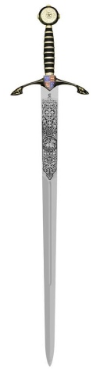
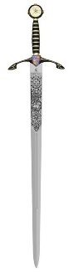
Excalibur
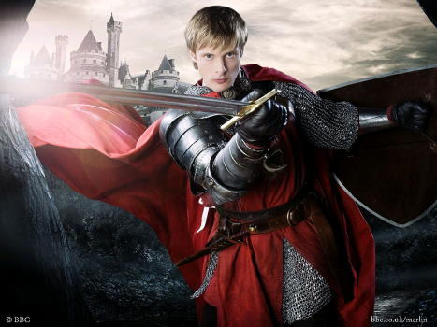
King Arthur made his court at Camelot and was a brave knight

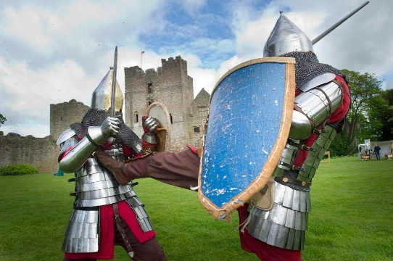
When King Arthur heard that Sir Pellinore was attaching travellers on the road to Camelot, he went to do battle. Arthur told Sir Pellinore to stand and fight. They fought hand to hand, their swords clashing, until Arthur’s sword broke.

But just in time, Merlin the magician appeared. He cast a sleeping spell on to Sir Pellinore. Merlin told Arthur not to worry about his broken sword. They were now on their way to fetch a finer sword, called Excalibur. They rode on until they came to a lake.

Out of the lake rose an arm clothed in white silk and holding the glittering sword Excalibur. Then from the mist drifted the Lady of the Lake. She took Arthur’s hand and helped him into a boat which glided, as if enchanted, towards the sword. As King Arthur took the sword, the lady vanished.

Arthur showed Excalibur to Merlin who told him that, although the sword would never break. Then Arthur and Merlin went home to Camelot where everyone rejoiced at the safe return of their brave king.

