Help Sheet for Describing St George

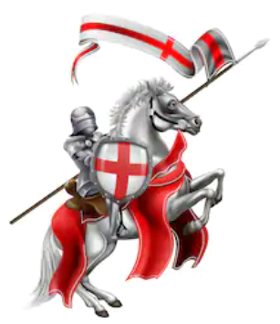
Synonyms for Brave
courageous
valiant
heroic
bold
daring
fearless

Weapons
sword
lance
axe
mace

What he might be wearing
helmet with a visor
gauntlets
shield
armour
cloak

Adjectives
sparking
gleaming
glistening
glowing
polished
burnished
dazzling

tough
sturdy
robust
solid

