Year 3 Maths Week Commencing 27.4.20
On https://login.mymaths.co.uk/ you should find your child has been set a daily my maths activity, in the same way that their my maths homework was set previously. If you have missed any, they can still be completed by clicking on the activity even if they say ‘overdue’.
Please also spend time practising times tables on https://ttrockstars.com/
Logins for both of these sites are in your child’s planner
For more daily maths activities see below;
If you have internet access, go to https://whiterosemaths.com/homelearning/year-3/
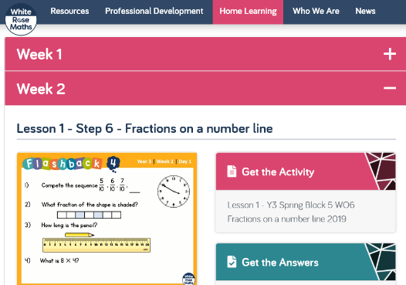
Click on Week 2, there is a short explanatory clip that explains the topic for the week.
Watch this before moving to the activity to complete.
Ideally, print out the activity, otherwise just answer questions from the screen.

Monday – Week 2 Lesson 1 Clip and Activity below;
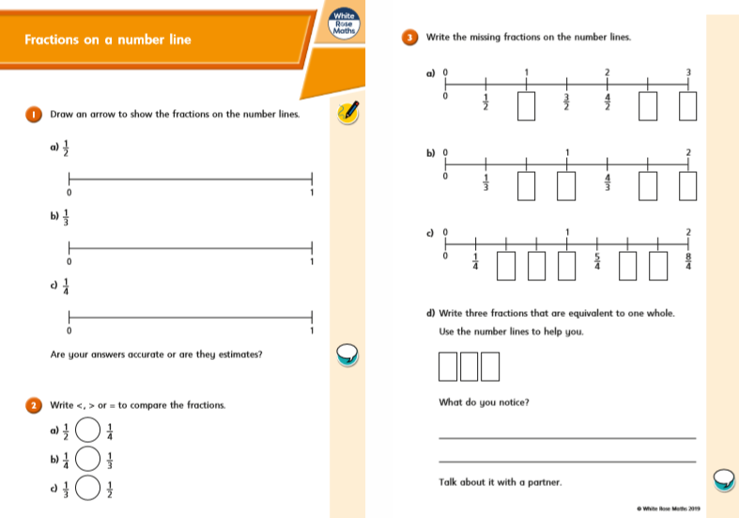
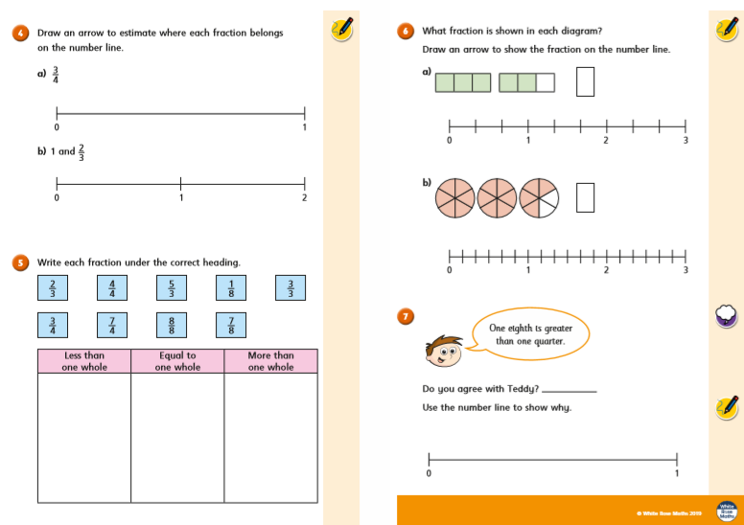
Tuesday Week 2 Lesson 2 Clip and Activity below;
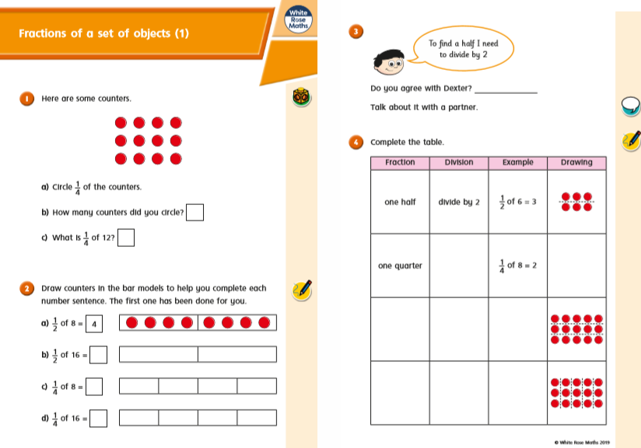
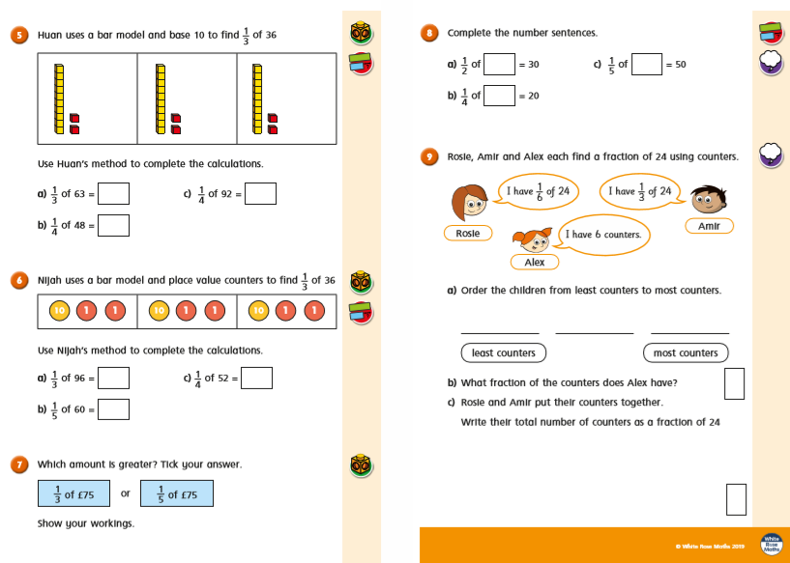
Wednesday Week 2 Lesson 3 Clip and Activity below;
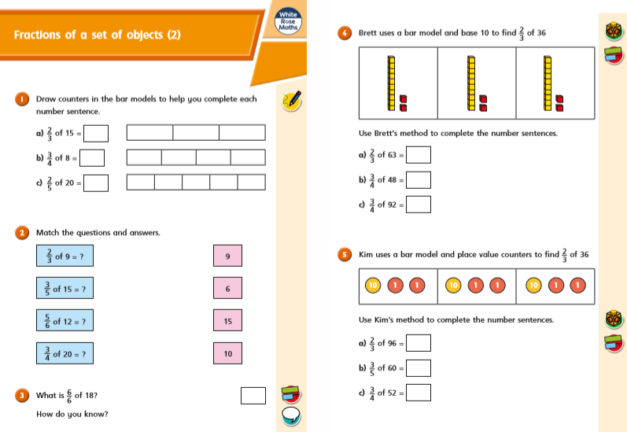
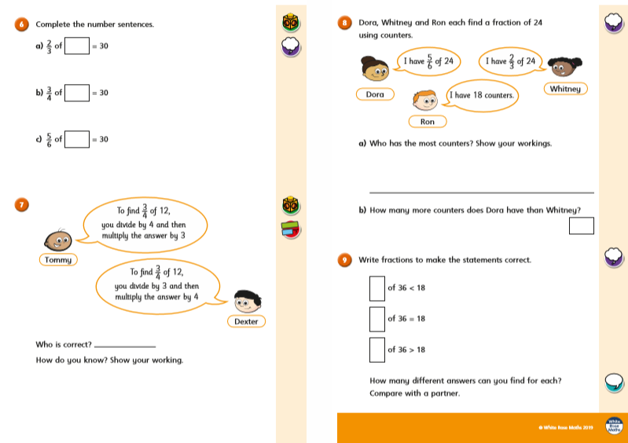

Thursday Week 2 Lesson 4 Clip and Activity below;
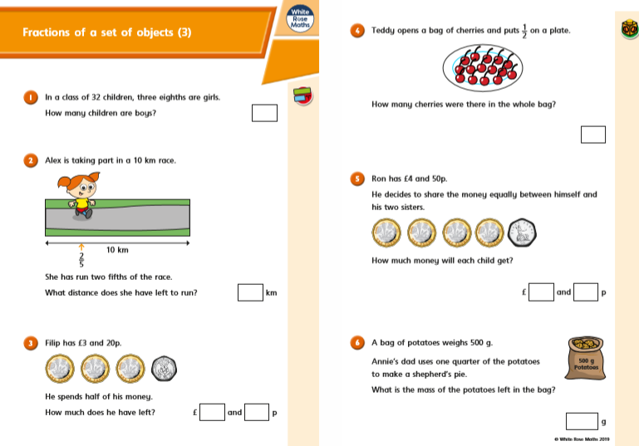
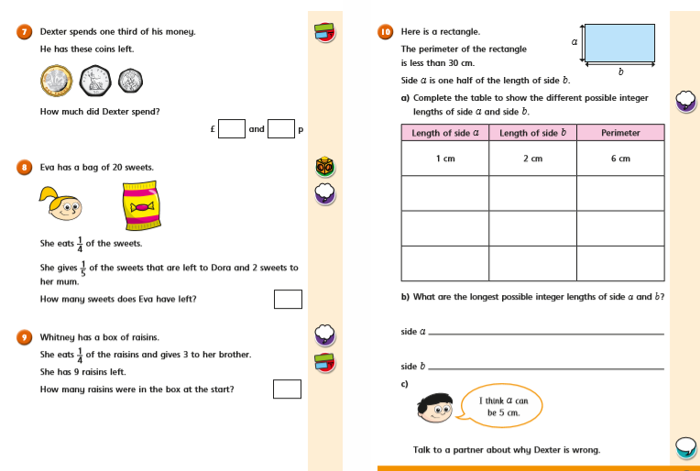

Friday Week 2 Lesson 5 Clip and Activity below;
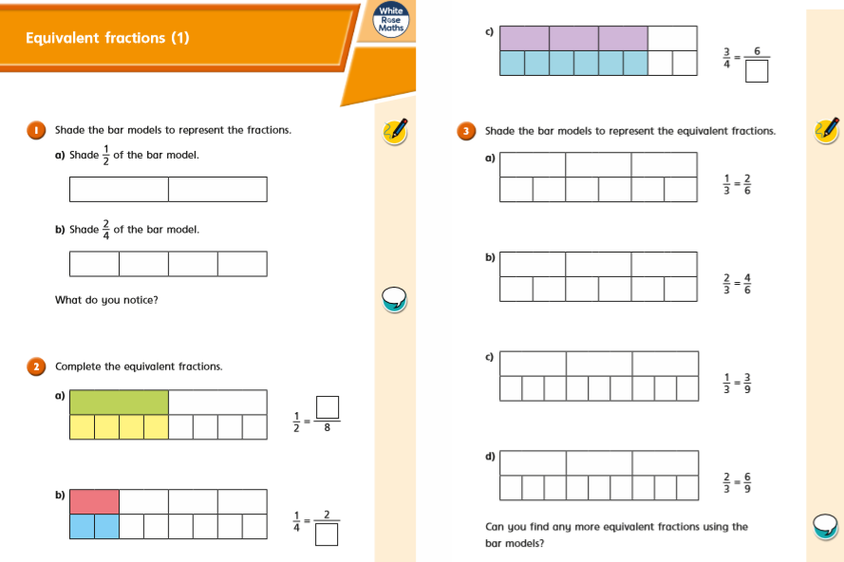
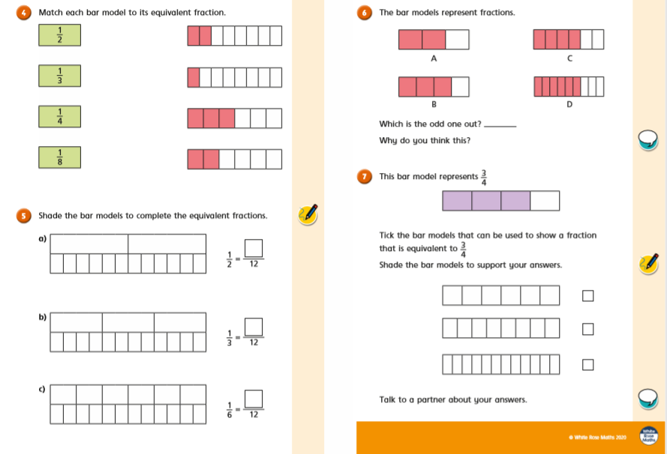

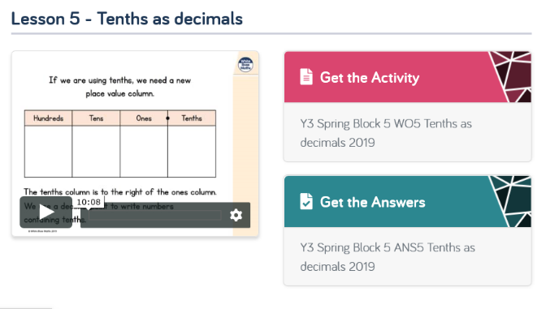

You will also find answer to each day’s activity by clicking here.

