
YEAR 3 Home-School Support W/C: 27.04.20
English Writing, Reading and GPS – Our Topic: Legends
Monday | What is a Legend?  We are continuing our learning about British legends this week. In the Year 3 Home Learning section there is the story of Excalibur (King Arthur’s legendary sword). Please read it (there is a mild version and a hot version). Why is this a legend? Here are the features of a legend. How many of these can you spot in the story?  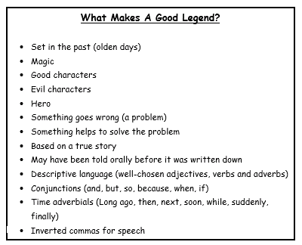
Tuesday | Reading and Dictionary work  Today, we are going to read another British legend: St. George and the Dragon. If you are struggling to read the story, ask a parent to help and both read it our loud together (we read aloud altogether a lot in class) or you could read along with Mrs Brown who has made a recording of her reading this story in the Year 3 section of Share Point.    Dictionary work: There are some tricky words in this story. Can you use a dictionary or the internet to find the meaning of these words?  stallion maiden  distress lair  villainous smote  sacrifice unfurled
Wednesday | Reading comprehension  Can you remember what some of those new, tricky words from yesterday meant?  Today, re-read the story of St. George from yesterday (or listen to Mrs Brown reading it on Share Point).  There are some comprehension questions about this on the Home Learning year 3 page. Choose either mild, hot or spicy. The answers are there too.
Thursday | To Describe the Character of St. George  Today, we are going to write a few sentences to describe St. George.  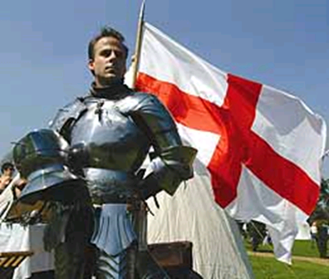  What might St. George be wearing?  What adjectives could you use to describe his armour?  Use a thesaurus to search for the word, ‘shining’. If you don’t have a thesaurus at home, search for an online thesaurus or use the thesaurus option on word under the ‘review’ tab. Also look up ‘brave’ in the thesaurus.  Take a look at the attached vocabulary list and also the model character description. Can you write your own description of St. George? It doesn’t need to be long, just 2 or 3 really good sentences.
Friday | Story Telling Task  Today, I would like to practise retelling the story of St. George in your own words. You do not need to write anything down. This is an oral story telling task and will help children to remember the story. We do this type of task a lot at school.  I have prepared a prompt sheet to help you which has some pictures from the story and some sentence starters. Try to include the wonderful description you wrote yesterday, describing the character of St. George.  Practise re-telling the story a few times until you are really good at it and you can tell it in an exciting way with lots of expression.    Once you are good at it, phone a Grandparent or a friend/relation and tell them the story on the phone. I bet they will love hearing it!
Handwriting
Monday | Worksheet attached for handwriting practise based around general Y3 statutory spellings. Do half of this sheet today and half tomorrow.
Tuesday | Finish the handwriting sheet from Monday.
Wednesday | Trace over the words from the poem, The Eagle by Alfred Lord Tennyson. The crooked hands means his claws. The poem is describing what the Eagle can see from being high up. At the end, he swoops down to catch his prey.
Thursday | Have a go at writing out the poem, The Eagle by yourself.
Friday | Can you write your short description of St. George out in best handwriting and decorate it?

Spellings for the week
Please use the attached ‘Spelling menu’ to find fun ways of learning your spellings! Also, use the games on the Spelling Shed website!

Blue Spellings
like
bike
five
time
ride
side
nine
line

Beige, Pink and Yellow Spellings
lyric
syrup
physics
oxygen
crystal
typical
physical
cylinder
sympathy
sympathetic

Guided Read on Share Point – Try logging on to Share Point and looking in the video library. Mrs Brown has uploaded several video clips of her reading a story called The Wizards of Once. This is great for your child to hear a story read aloud and would be like us having a guided reading session at school.
Maths
Please start/finish every day’s lesson with Times Table Rock Stars Practice.
There are also some activities on My Maths.
White Rose Maths – week 2 (Not summer term yet because we have only just started following this scheme and the lessons lead on from one another.)
Monday | https://whiterosemaths.com/homelearning/year-3/  Week 2, lesson 1: Fractions on a number line
Tuesday | https://whiterosemaths.com/homelearning/year-3/  Week 2, lesson 2: Fractions of a set of objects 1
Wednesday | https://whiterosemaths.com/homelearning/year-3/  Week 2, lesson 3: Fractions of a set of objects 2
Thursday | https://whiterosemaths.com/homelearning/year-3/  Week 2, lesson 4: Fractions of a set of objects 3
Friday | https://whiterosemaths.com/homelearning/year-3/  Week 2, lesson 5: Equivalent fractions  Keep an eye out on the school Twitter page for Mr Holland’s whole school maths challenge on Fri at 11:45 am! Tweet in your questions and solutions!

Creative
Monday | History  The Ancient Egyptians – Find out some background information about the Egyptians by following the links and then have a go at making either and Egyptian head-dress or some Egyptian jewellery.
Wednesday | History  Ancient Egypt – why was the river Nile important to Ancient Egyptians? Follow the links to find out about the River Nile and then choose a way to present your learning.
Friday | History  Ancient Egyptian hieroglyphics - follow the links to find out all about hieroglyphics and then present your learning using some of the ideas on the accompanying sheet.

Online Art Lessons
Mrs Garlick, one of our Church Hill teachers, is streaming a live online art lesson at 2.00pm weekdays. These are great fun for both children and adults and can be completed using general art equipment found in most homes. Mrs Garlick begins by giving some background information about an artist/techniques and then gives a comprehensive step by step guide to how to re-create a super piece of art work. This is streamed via a private Facebook group. This is a specialist group that Mrs Garlick has set up only for the purposes of streaming this live lesson and is no way connected to any of her personal account information. If you are interested in taking part in this, please can an adult request access. Here are the details:

https://www.facebook.com/groups/2800504326726539/?ref=share

If this link doesn’t work, search via Facebook for ‘Art with Mrs G’. Mrs Garlick will not be able to enter into any communications with parents via this but she will say well done if any children upload their art work.

PE
Monday- Friday | Watch out for Mr Partner’s PE challenges on Twitter every Monday!  PE with Joe  https://www.youtube.com/channel/UCAxW1XT0iEJo0TYlRfn6rYQ  Some other ideas:  Walk the dog, have a family walk, do some Cosmic Yoga, practise your times tables with BBC super-movers.  https://www.youtube.com/user/CosmicKidsYoga  https://www.bbc.co.uk/teach/supermovers/ks2-collection/zr4ky9q

Science
Tuesday | Mrs Kite’s Science challenge (attached information and resources). This week it is a parachute challenge.  Watch out on Twitter for Mrs Kite’s updates.

RE
Thursday | The Sikh Festival of Vaisakhi continued (attached information and resources). This is a second lesson leading on from last week’s.

Music
If you would like to try some online music lessons, follow this link:
https://www.youtube.com/channel/UC-iOnF1dIM8eagPO05SMnRQ
These are online lessons based around rhythms and body percussion.

