
YEAR 3 Home-School Support W/C: 20.04.20
English Writing, Reading and GPS
Monday |   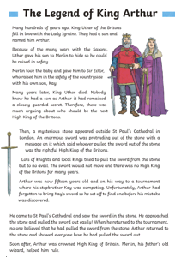  Today, read and enjoy the story of The Legend of King Arthur. If you are finding it tricky to read, ask a parent to read it for you or better still, you could both read it out loud together.  Watch this video clip for more information about King Arthur.  http://www.youtube.com/watch?v=Pa4v5gH3b18
Tuesday | Today there are some questions based on the story from yesterday: The Legend of King Arthur. The mild questions are easy, hot are at the expected standard for Year 3 and spicy questions are more challenging. The answer for hot and spicy are also provided. You get to choose your level of challenge; choose either mild, or hot or spicy - you are not expected to do all 3.
Wednesday | Planning a story  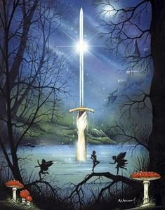  Can you help King Arthur find a new sword when his gets broken?  Over the next 3 days, we are going to plan, write and edit a short story based on this picture and this opening.  King Arthur ruled England from the mighty castle, Camelot. Bravely he defended the kingdom from enemies; however, whilst battling an evil knight who had been attacking travellers, Arthur’s sword was broken.  Today, try to plan what will happen to finish this story.  To be awesome, your story should include:  - Descriptions of the setting and King Arthur  - Remember this story is set in the past before people had cars and technology. King Arthur would have travelled by horse.  - Try to include a bit of speech to move your story forwards but don’t use too much speech. Balance speech and description.  Planning:  Where: Camelot  Who: King Arthur  Where next: ?  Why: For a new sword  What goes wrong: ?  Who helps: ?  Where last: ?  How does Arthur feel at the end: ?
Thursday | Today have a go at writing your story based on yesterday’s plan.  Here is the opening of your story….  King Arthur ruled England from the mighty castle, Camelot. Bravely he defended the kingdom from enemies; however, whilst battling an evil knight who had been attacking travellers, Arthur’s sword was broken.
Friday | Edit your writing. Read through with a critical eye. How is punctuation looking? Focus on the basics first: capitals, full stops, question mark and exclamation marks.  Then look at higher level punctuation:  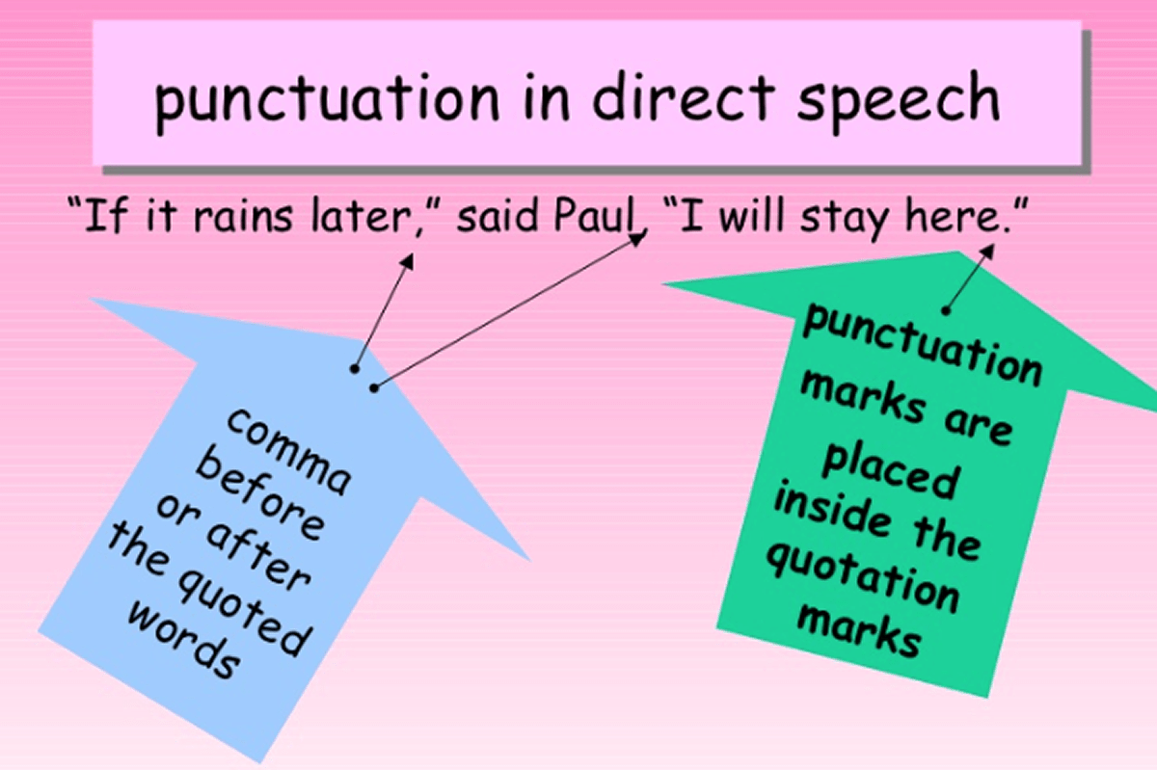  Before school closed, we taught you how to use inverted commas (speech marks). Have you used them correctly?  Do you need commas for lists or commas to separate a main clause and a subordinate clause?  It would be lovely if you could share some of your stories on our school’s Twitter.
Handwriting
Monday | Worksheet attached for handwriting practise based around your spellings. Do half of this sheet today and half tomorrow.
Tuesday | Finish the handwriting sheet from Monday.
Wednesday | Trace over the words from the poem, The Crocodile by Lewis Carroll.
Thursday | Have a go at writing out the poem, The Crocodile by yourself.
Friday | Can you learn the poem The Crocodile off by heart? Once you can remember it, phone a friend or relative and recite it to them over the phone.

Spellings for the week
Please use the attached ‘Spelling menu’ to find fun ways of learning your spellings! Also, use the games on the Spelling Shed website!
Beige, Pink and Yellow Spellings
myth
gym
hymn
Egypt
pyramid
crypt
symbol
mystery
mystical
mysterious
Blue Spellings
made
make
name
came
same
safe
gave
take

Maths
Please start/finish every day’s lesson with Times Table Rock Stars Practice.
Monday | https://whiterosemaths.com/homelearning/year-3/  Week 1, lesson 1: Unit and non-unit fractions
Tuesday | https://whiterosemaths.com/homelearning/year-3/  Week 1, lesson 2: Making the whole
Wednesday | https://whiterosemaths.com/homelearning/year-3/  Week 1, lesson 3: Tenths
Thursday | https://whiterosemaths.com/homelearning/year-3/  Week 1, lesson 4: Count in Tenths
Friday | https://whiterosemaths.com/homelearning/year-3/  Week 1, lesson 5: Tenths as decimals  Keep an eye out on the school Twitter page for Mr Holland’s whole school maths challenge at 11:45 am! Tweet in your questions and solutions!

Creative
Monday | Science  Amazing Animals – researching carnivores, herbivores and omnivores. See the attached information for web links and resources.
Wednesday | Art  Leading on from Monday’s lesson, draw and pictures/paint/make a model of an animal. Is it a carnivore, herbivore or omnivore?
Friday | Science  Describing different animals. Follow the liks to find out about different types of animals (mammals, reptile, birds, fish, amphibians, insects) and create some top trumps cards. Again, see the attached information.

Online Art Lessons
Mrs Garlick, one of our Church Hill teachers, is streaming a live online art lesson at 2.00pm weekdays. These are great fun for both children and adults and can be completed using general art equipment found in most homes. Mrs Garlick begins by giving some background information about an artist/techniques and then gives a comprehensive step by step guide to how to re-create a super piece of art work. This is streamed via a private Facebook group. This is a specialist group that Mrs Garlick has set up only for the purposes of streaming this live lesson and is no way connected to any of her personal account information. If you are interested in taking part in this, please can an adult request access. Here are the details:

https://www.facebook.com/groups/2800504326726539/?ref=share

If this link doesn’t work, search via Facebook for ‘Art with Mrs G’. Mrs Garlick will not be able to enter into any communications with parents via this but she will say well done if any children upload their art work.

PE
Monday- Friday | Watch out for Mr Partner’s PE challenges on Twitter every Monday!  PE with Joe  https://www.youtube.com/channel/UCAxW1XT0iEJo0TYlRfn6rYQ  Some other ideas:  Walk the dog, have a family walk, do some Cosmic Yoga, practise your times tables with BBC super-movers.  https://www.youtube.com/user/CosmicKidsYoga  https://www.bbc.co.uk/teach/supermovers/ks2-collection/zr4ky9q

Science
Tuesday | Mrs Kite’s Science challenge (attached information and resources).  Watch out on Twitter for Mrs Kite’s updates.

RE
Thursday | The Sikh Festival of Vaisakhi (attached information and resources).

