Dear Parent / Carers,
This lesson focuses on the Sikh religion. Please watch the clip and answer / draw the responses in the sections provided.


The Sikh Festival of Vaisakhi
This work is all about how Sikh people remember a story from the life of the Tenth Guru, who is called Guru Govind Singh, and lived over 300 years ago in India. The story is remembered at the Sikh festival of Vaisakhi. There are nearly half a million Sikh people in the UK today, and millions more in India and other parts of the world.
Start by watching the short film about Simran’s Vaisakhi – she is
11. You can watch it here: https://www.bbc.co.uk/programmes/p02mx76l

Can you remember 5 fascinating facts from the film? Can you remember 5 key words? Note them down.

Note to parents and carers: This set of home learning ideas for 7-11 year olds uses two of the BBC My Life, My Religion films. Children can access these films via the links and QR codes provided.



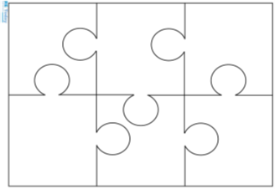
Simran’s identity
Our festivals are a way of showing our identity. Our identities are who we think we are, and can include our friends and family, values, beliefs and behaviours that we think are important. Imagine Simran’s identity as a jigsaw: can you draw into this jigsaw six things about her life, and label your drawings?
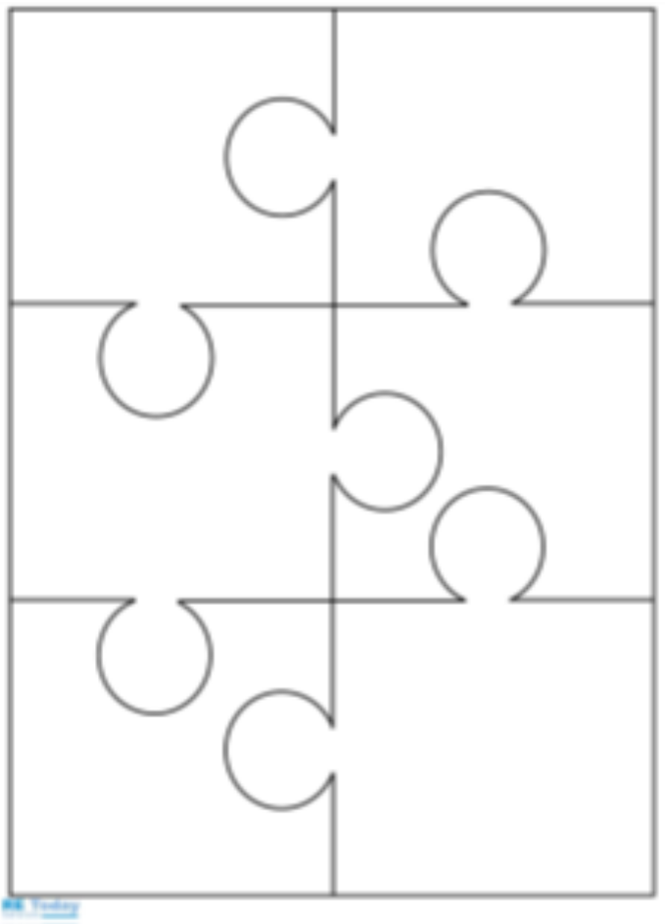

Your identity
Now think about your own identity. Make a jigsaw that shows six things about you – maybe things to do with family, festivals, your beliefs, favourite places, songs or films, pets – all the things that matter most to you. Label your drawings in detail.

Compare the two jigsaws, yours and Simran’s. Can you see some similarities and differences? We are all humans, so we can often find both similarities and differences between ourselves.

Similarities and differences
Simran and myself are similar because…

Simran and myself are different because…

‘We are all human’. What I think about this phrase is…

