
Science – Week 2
Parachutes
Resources needed:
- Different materials such as carrier bag, paper, fabric etc…
- Some string or wool or thread
- Plastic small toy or piece of Lego
Instructions.
- Cut a circle out of your material. Decide what size you would like.
- Punch/make four holes around the edge of the circle.
- Tie string/wool/thread to each hole. The pieces should be the same length.
- Tie the strings together under the parachute and secure your object.
- Test.
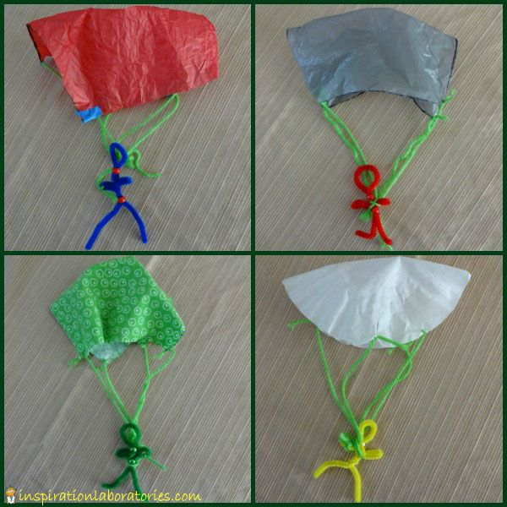
- Repeat with a different type of material.
Which material worked the best? Why?
How long did it take to fall to the floor?
How could you improve your parachute?
What would happen if you changed your plastic toy? Could you make it lighter or heavier?
What would happen if you changed the length of your string?

What is happening? Air resistance pushes up on the parachute, opposing the force of gravity and making the parachute and the person fall more slowly.

If you want to find out more about parachutes:
https://www.explainthatstuff.com/how-parachutes-work.html
https://www.kidsdiscover.com/teacherresources/parachutes-gravity-air-resistance/
https://www.bbc.co.uk/bitesize/clips/zsjd7ty

Remember to tweet any pictures and clips to @ChurchHillJS

