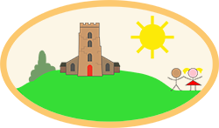
YEAR 4 Home-School Support W/C: 27.04.20
Writing including Grammar
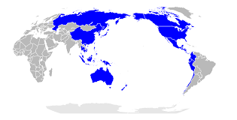
Our new theme for English is stories from another culture, particularly the stories from countries in the Pacific Rim. Here is a map to show the countries (in blue) that border the Pacific Ocean. Australia is one of these. We are looking at Australia because Aborigines (indigenous, native people who are descended from groups that lived in Australia before the British settled there) have the longest surviving cultural history on Earth. It is between 50,000 and 60,000 years old. We will look at the ‘Dreaming stories’. The Aboriginal Dreaming means ‘to see and understand the law’. It is the way the Aborigines pass on important knowledge, cultural values and belief systems to future generations. Their stories focus on how animals evolved.
Monday | Read ‘How the birds got their colours’.  Complete the questions to show your understanding of the story.
Tuesday | Read ‘How the birds got their colours’.  Complete the story analysis sheet to show your understanding of the story.  Watch out for a class reader with your Year group on Twitter!
Wednesday | Look through the story analysis sheet that you completed yesterday. Use the blank sheet to help you plan your own British cultural story of ‘How the .... got its ….’ This could be How the hedgehog got its prickles, Why the squirrel has a bushy tail, How the badger came to be black and white or one of your own choices.  Make sure you talk through your ideas with someone and base the reasons in nature as the Aborigines did. Complete your sheet to show your ideas.
Thursday | Read the ‘How the birds got their colours’ story again. This time identify the nouns in red, the adjectives in green and the verbs in yellow. See how they link to the poem about the crow.  Have a go at identifying key nouns, adjectives and verbs for your planned story. Think about how your animal moves and behaves. What do they look like? Where do they live? What is around them? Use them to write a diamante poem like ‘The Crow’, following the structure of 1 noun, 2 adjectives & so on Upload your poems onto Sharepoint. Why not share them on Twitter too if you can!  Watch out for a class reader with your Year group on Twitter!
Friday | Read the Haiku poem about the birds.  Can you create one for your own animal in your story.  Try to follow the rules and upload your finished poems. We would love to read them. It would be lovely if you could illustrate it too!

Handwriting
Monday | 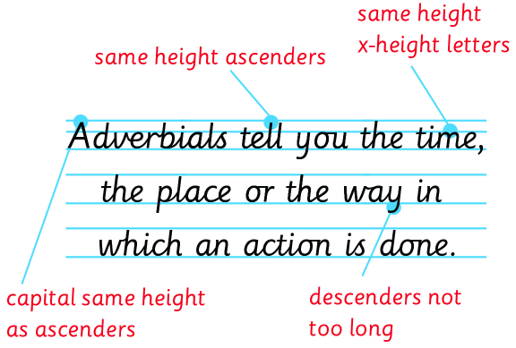  Size, proportion and Spacing  Image 1) Have a go at writing this sentence, making sure you think about the size and joins of each letter. Yours should look the same as the picture.  Identify where you could improve and rewrite the sentence. Repeat as many times as necessary. Write out a list of adverbials underneath, e.g. After, Earlier, The next morning, occasionally...
Tuesday | See handwriting sheet for adverbials. Concentrate on your handwriting and place each adverbial under the correct heading. Then add a few of your own.
Wednesday | Complete the size, proportion and spacing worksheet on the handwriting document.
Thursday | Complete the size, proportion and spacing worksheet on the handwriting document.

Spellings for the week
Ants - High frequency words. Plus, some key Y3&4 words.
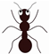  Ants | length | library | material | green
 | grow | hard | head | home

Bees – learn the first 12
Caterpillars – bees words plus next line. Dragonflies – as caterpillars, plus next line.

Use the prefixes in-, im-, il-
RULE
Prefixes change the meaning of a root word.
In- before a word can mean ‘in’, ‘on’ or ‘not’. It is used when the root word
Im- before a word can mean ‘no’ or ‘not’ It is used with some adjectives and nouns that begin with 'b', 'm', and 'p' to give the opposite meaning.
Il- before a word can mean ‘no’ or ‘not’. It is used with some adjectives and nouns that begin with 'l' to give the opposite meaning.

  Bees | length | library | material | medicine
 | inactive | immortal | illegal | imperfect
 | incorrect | immoral | illogical | inaccurate
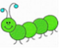  Caterpillars | incredible | immature | illuminate | impolite
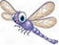  Dragonflies | independent | impossible | illegible | immoveable

Please use the attached ‘Spelling menu’ to encourage learning.
Maths
Finish every day’s lesson with Times Table Rock Stars Practice.
https://whiterosemaths.com/homelearning/year-4/ White Rose Maths – week 2 (Not summer term yet because we have only just started following this scheme and the lessons lead on from one another.)
Monday | Week 2: Lesson 1- Divide 2 digits by 10
Tuesday | Week 2: Lesson 2- Hundredths
Wednesday | Week 2: Lesson 3- Hundredths as decimals
Thursday | Week 2: Lesson 4- Hundredths on a place value grid
Friday | Week 2: Lesson 5- Divide 1 or 2 digits by 100.  Keep an eye out on the school Twitter page for Mr Holland’s whole school maths challenge on Fri at 11:45 am! Tweet in your questions and solutions!
Why not try some active maths too. Select your year group, teaching objective and have fun!
https://www.teachactive.org/my-account/?code=CESUV

Creative
Monday | Alphabets  The Scots and Picts didn’t leave much evidence behind as they didn’t write things down. However, we can learn a lot about them from the standing stones they carved. Some stones show text written in ‘Ogham’. This was an alphabet used by the Picts and Scots.  See the information sheet attached and have a go at using the Ogham alphabet.
Wednesday | Anglo-Saxon Games  On the sheet are three examples of popular Anglo Saxon board games- Taefl, Tabula and Merels; You can either print off the boards and counters or make your own version. Learn the rules and play with your family.
Friday | Cooking  The Anglo-Saxons enjoyed food and drink as much as we do and they often held big feasts. Use the sheet to learn about the different methods the Anglo-Saxons used and then have a go at some baking!
Don’t forget to tweet your work @ChurchHillJS
PE
Monday- Friday | Watch out for Mr Partner’s PE challenges on Twitter every Monday!  PE with Joe  https://www.youtube.com/channel/UCAxW1XT0iEJo0TYlRfn6rYQ

Science
Tuesday | Mrs Kite’s Parachute Science challenge (attached information and resources).  Watch out on Twitter for Mrs Kite’s updates.

RE
Thursday | This lesson follows on from last week’s learning. Please watch the clip and answer / draw the responses in the sections provided. You might like to use an extra sheet for describing a personal sacrifice at the end of this lesson.

