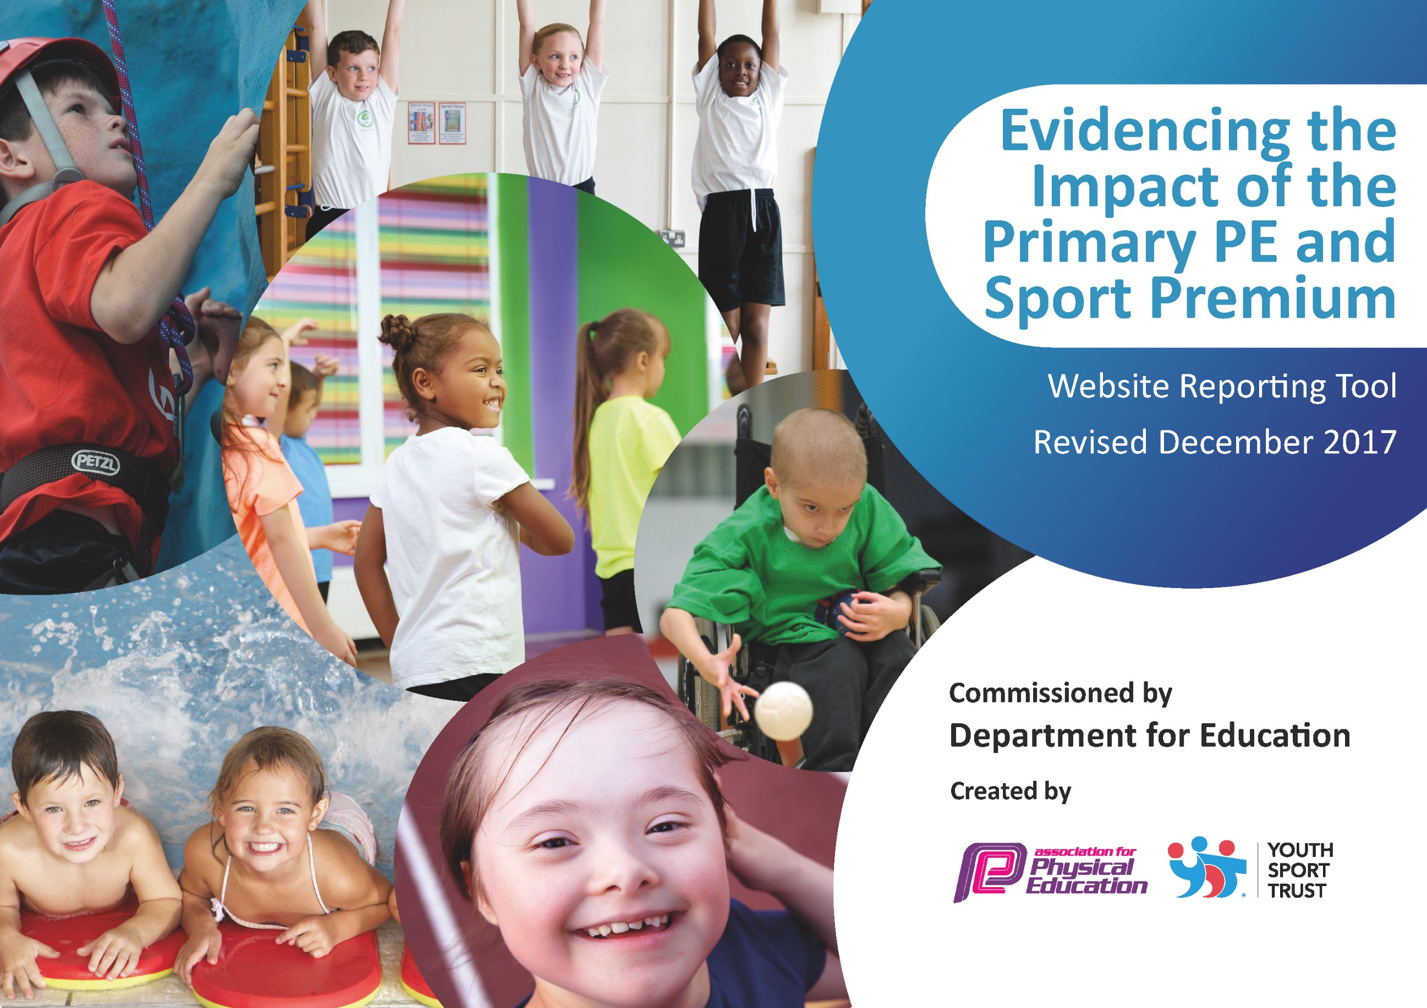

Schools must use the funding to make additional and sustainable improvements to the quality of PE and sport they offer. This means that you should use the Primary PE and Sport Premium to:

- develop or add to the PE and sport activities that your school already offers
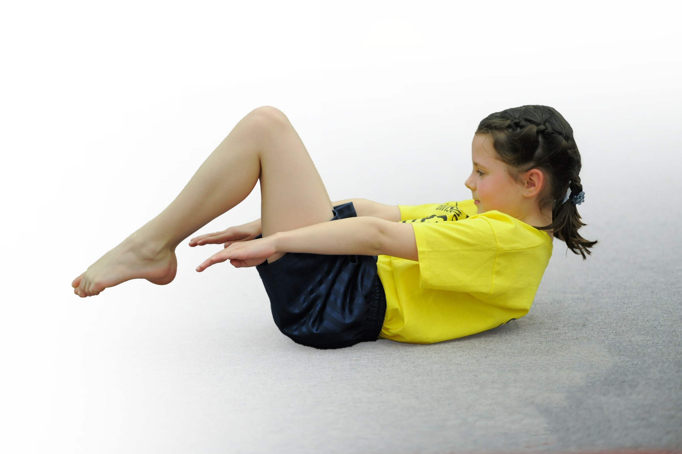
- build capacity and capability within the school to ensure that improvements made now will benefit pupils joining the school in future years

Please visit gov.uk for the revised DfE guidance including the 5 key indicators across which schools should demonstrate an improvement. This document will help you to review your provision and to report your spend. DfE encourages schools to use this template as an effective way of meeting the reporting requirements of the Primary PE and Sport Premium.

We recommend you start by reflecting on the impact of current provision and reviewing the previous spend.
Under the Ofsted Schools Inspection Framework, inspectors will assess how effectively leaders use
the Primary PE and Sport Premium and measure its impact on outcomes for pupils, and how effectively governors hold them to account
for this.

Schools are required to publish details of how they spend this funding as well as on the impact it has on pupils’ PE
and sport participation and attainment.
We recommend regularly updating the table and
publishing it on your website as evidence
of your ongoing review into how you are using the money
to secure maximum, sustainable impact. To see an example of how to complete the table please click HERE.

Action Plan and Budget Tracking
Capture your intended annual spend against the 5 key indicators. Clarify the success criteria and evidence of impact that you intend to measure to evaluate for students today and for the future.

Academic Year: 2017/18 | Total fund allocated: £19,140 | Date Updated:04/07/18
Key indicator 1: The engagement of all pupils in regular physical activity – Chief Medical Officer guidelines recommend that primary school children undertake at least 30 minutes of physical activity a day in school |  |  |  | Percentage of total allocation:
 |  |  |  | %
School focus with clarity on intended impact on pupils: | Actions to achieve: | Funding allocated: | Evidence and impact: | Sustainability and suggested next steps:
All primary school children  undertake at least 30 minutes of  physical activity a day in school –  improve social, emotional and  physical health of all pupils. | Daily Mile carried out by all classes.  Yr 3 & 4 Swimming groups walk to Round Hill on a Thursday  Wake n Shake – Sports Leaders delivered movements routines on Thursday mornings weekly throughout the year.  Lunch time - PE lunch time sports coach employed for the year offering various sporting activities.  Extra Curr Clubs – Extensive programme offering a different activity every day of the week.  Swimming – Year 3 & 4 have been swimming at Roundhill Academy including a 20 minute walk to get to the pool. | £200 outdoor PA system purchased.  £5812.50 | 20-30 children regularly follow the 12 sports leaders in dance movements for 10 minutes every Thursday morning.  Daily mile being followed by some classes but not all and weather has an impact on field.  Children have taken part in lunch time sporting activities, house competition including the highly popular marathon challenge and world cup football competition.  Extra-curricular TT, Invite letters home and photographic evidence published on website. 49% (164) of children in the school have taken part in PE Extra Curricular clubs this year compared to 18% (62) children last year. | Do wake & shake at least twice a week and aim to introduce a physical 5 to all les  Produce a timetable for classes to add weight to the necessity to do this.  Sports leaders to be utilized to run activities with supervision from lunch time supervisors.  Continue with swimming at Round hill with a view to develop existing swimming pool on school site.
Key indicator 2: The profile of PE and sport being raised across the school as a tool for whole school improvement |  |  |  | Percentage of total allocation:
 |  |  |  | %
School focus with clarity on intended impact on pupils: | Actions to achieve: | Funding allocated: | Evidence and impact: | Sustainability and suggested next steps:
To raise the profile of PE and sport  across the school – more pupils  engaged in a wider variety of physical  activities in lessons and extra-curricular sessions. | Offer a wider variety of sporting activities throughout the year.  Assemblies led by Leicester Riders, Leicester Tigers, Leicestershire County Cricket and Red star Judo Club to raise profile of Basketball, Rugby, | £2525.00 | 1 before/13 after school clubs have taken place this year with 228 participants attending (some children attend more than one club). | School Judo Club established and forms links to Red Star Judo Club.

Key indicator 3: Increased confidence, knowledge and skills of all staff in teaching PE and sport |  |  |  | Percentage of total allocation:
 |  |  |  | %
School focus with clarity on intended  impact on pupils: | Actions to achieve: | Funding  allocated: | Evidence and impact: | Sustainability and suggested  next steps:
Increased confidence, knowledge and  skills of all staff in teaching PE and  sport through CPD, external coaches  and team teaching with school staff –  pupils will receive high quality PE  and school sports. | Purchased Val Sabin Lesson plan resources to ensure high quality teaching of Gymnastics, Dance, Games and Athletics.  External coaches – Darren Merrimen, Dom Owen Leicester Tigers, Tom Flowers Cricket, Helen Jelly hockey have all delivered curriculum PE essions with CHJS staff supporting and observing to improve own CPD.  Team Charnwood - Get active, Get Fit teacher training course attended by SP & AO | £418  Free part of £850 Sub to TC  £2000 | CHJS PE Staff using in PE lessons. | Observations by PE Coordinator.
Key indicator 4: Broader experience of a range of sports and activities offered to all pupils |  |  |  | Percentage of total allocation:
 |  |  |  | %
School focus with clarity on intended  impact on pupils: | Actions to achieve: | Funding  allocated: | Evidence and impact: | Sustainability and suggested  next steps:
Additional achievements: continue to  offer a wide range of activities both  within and outside the curriculum in  order to maximise pupil involvement.  PE coordinator to focus particularly on involving pupils that do not take up additional PE and sport opportunities. | Cross country club well established by SP with races on Saturdays as throughout the year at Preswold Hall. Race subscription fees, 18x new school Vests and school flag purchased  AO led a multi sports club targeting 10 SEN children for 6 weeks  SP took Bl & S/E children to inclusive football competition  EH has led Football competitions at Wreake Valley for boys and girls in year 5&6.  Team Charnwood - Dance festival, Tri-golf festival, Flames Multi skill festival, Indoor Athletics, Quadkids Athletics and Tag Rugby inter sport competitions attended.  Mobile Beaumanor Hall Climbing Wall – 125 students in July 2018 | £3000 | 15 Children attending Wednesday morning cross country club and competing in countywide races on Saturday mornings.  3 children selected to represent South Charnwood this year.  55% of all SEN children have participated in an after school club.
Key indicator 5: Increased participation in competitive sport |  |  |  | Percentage of total allocation:
 |  |  |  | %
School focus with clarity on intended  impact on pupils: | Actions to achieve: | Funding  allocated: | Evidence and impact: | Sustainability and suggested  next steps:
Continue to enter existing and new  School Games competitions and local  sports events.  Identify and target less active pupils  and engage in competitive activities. | Attend level 2 Team Charnwood School Games Competitions. | £2000 | EH has led Football competitions at Wreake Valley for boys and girls in year 5&6.  SP has taken children to Team Charnwood Level 2 School Games competitive competitions - Tri-golf, Indoor Athletics, Quadkids Athletics and Tag Rugby. | Next steps:Enter orienteering competitions.  Take part in Brownlee Triathlon  event.  Boccia and Sportability clubs and  competitions.  Introduce level 0 School Games  challenges

