
YEAR 5 Home-School Support W/C: 20.04.20
English Writing including Grammar
 | Year 5 will be learning the skills of Persuasive writing this term and we begin this week with a persuasive argument to persuade George he should eat a more healthy and varied diet.
Monday | Begin by reading the sample text about text messaging to get a feel for what you will be expected to produce this week.  Next print off the persuasion writing template and look how we are going to structure our writing this week. It is worth stressing at this point that the children must choose only one side of the argument to write about and stick to this throughout their work. They have to either be in favour or against but not both!  Let’s now look at the PowerPoint presentation attached called persuasion word tower and focus on the slide language of time / sequence. Awesome writers use this type of language in their arguments.  Step 1 - Underline or highlight any language of time sequence used in the sample text about text messaging.  Now look at slides 3 & 4 about the language of cause and effect.  Step 2 – Choose a different colour and underline or highlight any language of cause and effect used in the sample text.  Step 3 – Read slide 5 - language of modality and highlight in a 3rd colour any examples found in the sample text.
Tuesday  Tues cont… | Print It – Tuesday student worksheet  Begin by reading this information about George.  Today’s Tasks  Record answers on the worksheet attached to email or on a piece of paper.  Step one: What questions can we ask George about his eating?  Step two: Give five reasons why it is important to eat lots of different foods each day.  Step three: Do you have any evidence? What could happen if George doesn’t change his diet?  Step four: Below are some words and phrases you could use when writing to George to try and convince him to eat more healthily. Finish each sentence starter to try and convince George to change his fussy eating habits.  - I think...  - I know…  - You must…  - What if…  - It’s important to…  Challenge – Can you use modal verbs when trying to persuade George to change his eating habits.
   | This is George. He is 8 years old and loves sports of any kind. He plays in defence on the school basketball team and is the top goal scorer in his local football club!  Keeping fit is very important to him so in his spare time he jogs with his brother Jack.  Life seems to be good for George but his family are worried about him and they need some help from you.  George is a fussy eater. His family try hard to persuade him to eat more healthily but he will only eat cheese and tomato pizza and hotdogs with lots of ketchup. Nothing else! Breakfast for George doesn’t exist.
Wednesday | Print It – Wednesday persuasion writing template  Today we will begin to write an argument to persuade George he should eat a healthier and varied diet.  Read the title and statement of position (the side of the argument you sit on).  Writing your 1st argument paragraph  - Look back at step 2 from Tuesday’s lesson. Choose your strongest reason for George to change his habits and draft ideas to explain your point of view.  - In one paragraph, explain/elaborate your key message by giving evidence or examples to really reinforce your point.  - Try to use the language of time sequence to begin sentences and add order to your arguments  - Don’t forget the language of cause and effect and modality to create make your points seem more powerful and convincing.  Edit it - Proof read your work and edit it before writing up your first argument in best on the Writing template provided.  Now repeat the steps above but choosing your second argument. Complete argument 2 box on the template.
Thursday | Today you will complete your Persuasive piece of writing - argument 3 and the conclusion.  Re-read the sample text on text messaging to gain ideas on how to summarise your arguments and bring to a conclusion. Usually this is done using a technique known as the power of 3 - The writer lists 3 points with each one getting slightly more convincing to the reader and leaving little doubt on what George should do next.
Friday | Proof read your persuasive piece of writing. Read through with a critical eye. What word choices or phrases have you included to really persuade George to eat healthily. Did you use any of the phrases from Tuesday step 4? Edit your work where necessary.

Handwriting
Monday | Complete PENPALS unit 11 – See attached sheet so that you can print it out.
Tuesday | Complete PENPALS unit 12 – See attached sheet so that you can print it out.
Wednesday | Read then copy out this paragraph on lined paper in your best handwriting.  The Vikings were not just renowned warriors, they also had a poetic side to their culture. They would think about objects in a metaphorical way and we call the poetic form that they created “kennings”.
Thursday | Read then copy out this paragraph on lined paper in your best handwriting.  Kennings are expressions that name something without using its name. As the Vikings were warriors, many of their kennings were to do with battles and fighting.
Friday | Write out the 10 Viking kennings below  - Counsel giver = Friend  - Storm of weapons = Battle  - Wound bees = Arrows  - Slaughter dew = Blood  - Sea beast = Boat  - Tree of battle = Man  - Jewellery tree = Woman  - Wand of battle = Sword  - Overbearer = Enemy  - Valiant apple tree of life = Brave warrior

Spellings for the week ending Friday 24.4.20
Look out for Mrs Shilton inviting each spelling group to a join a live spelling HIVE group on Friday 24th April. The children can practise their spellings in a fun and interactive way at https://www.spellingshed.com/en-gb
Grapes | Oranges | Grapefruit | Melons
- special  - official  - social  - shelve  - shelves  - miss  - misses  - missed  - missing  - curve  - curved  - curves  - more  - before | - mansion  - pension  - tension  - explosion  - session  - mission  - passion  - fiction  - fraction  - direction  - magician  - optician  - ocean  - narrator  - programme  - recommend | - continent  - continental  - telepathy  - telephoto  - television  - recite  - December  - convenient  - inconvenient  - attentive  - inattentive  - inverted  - exclude  - exclusion  - include  - inclusion  - compete  - competition | - continent  - continental  - telepathy  - telephoto  - television  - recite  - December  - inconvenient  - inattentive  - inverted  - exclude  - exclusion  - inclusion  - gently  - hungrily  - competition  - pollution  - marvellous  - beneficial  - excellent

Maths
Finish every day’s lesson with Times Table Rock Stars Practice. https://ttrockstars.com/
Monday | White Rose Math  https://whiterosemaths.com/homelearning/year-5/  Each day there is a short vide to watch and then have a go at the task. If you can’t print it off just write your answers on paper.  Try to complete Week 1 Lesson 1 – Lesson 4 this week  Keep an eye out on the school Twitter page for Mr Holland’s whole school maths challenge at 11:45 am! Tweet in your questions and solutions!
Tuesday
Wednesday
Thursday
Friday
Science
 | Mrs Kite’s Science Weekly Challenge - Walking Water Experiment  See attached Science Week 1 instructions – Don’t forget to tweet when you have completed it. We’d love to see what you have been doing.  Watch out on Twitter for Mrs Kite’s updates.

Creative
Monday | ART linked to History  Choose five Viking kennings from the handwriting task on Friday. Create a poster for primary school children to explain what they are.  Include:-  - Visual representations of your kenning.  - The actual words.  - An explanation of what a kenning is.  Challenge – Take it further if you wish by creating your own Viking kennings
Tuesday | Art linked to History  Old Viking letters are called runes. Find a smooth pebble from your garden or from a walk with the family and paint it. Then mark on your first letter or initials onto the pebble with a black pen. Remember the Vikings used straight lines. Perhaps you can do more than one in different designs and spell out CHJS or your name. Remember runes only use straight lines. Once you’ve made your runes, write your name or make a message for someone in your family. We’d love to see how you get on!  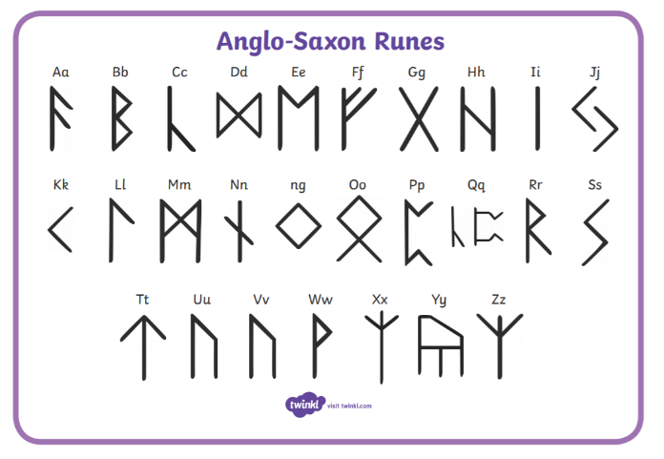
Wednesday | Online Art lesson with our very own Mrs Garlic  The school have recently sent out details to all parents of how to view live Art lessons at 2pm each week day delivered by our very own Mrs Garlic (Year 3 Teacher at CHJS). Use these details for all her Art lessons. Here is one to do with sculptures using kitchen foil.  See attachment for details of her lesson all about Alberto Giacometti
Thursday | Music - Join in with one of the ‘Body Beats’ body percussion online sessions this week, which take place daily on YouTube at 1pm.  https://www.youtube.com/user/OllieTunmer  Perhaps you can persuade members of you family to join in as well. Can you create your own body beats rhythms using the body percussion ideas you’ve learnt? Teach the routine to a member of your family. Let us know how you get on!
Friday | Personal Social Health Education (PSHE)  Draw a family flag showing the skills and talents of each of your family members. See attached template.

PE
Monday - Friday | Watch out for Mr Partner’s PE challenges on Twitter every Monday!  PE with Joe Wicks  https://www.youtube.com/channel/UCAxW1XT0iEJo0TYlRfn6rYQ  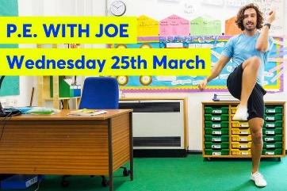  Some other ideas:  Walk the dog or have a family walk  Try Cosmic Yoga  Practise your times tables with BBC super-movers.  https://www.youtube.com/user/CosmicKidsYoga  https://www.bbc.co.uk/teach/supermovers/ks2-collection/zr4ky9q  Real PE at home – online learning resources  real PE at home includes an online programme which supports families to be active, play and learn together. It includes a programme for children in Key Stage 2, with daily and weekly guidance provided for both programmes (starting from next week) in addition to an option to choose your own themes and activities.  There are so many benefits to being active, not only to our physical wellbeing but also to our emotional and mental health, especially in such testing times for all of us. We hope that the ideas help support you and your family to stay fit and healthy in the coming months. Here are the details to access real PE at home:  The website address is: home.jasmineactive.com  Parent email: parent@churchhill-1.com  Password: churchhill  Click here to view more information to support you including a user guide and FAQs.  You can view what real PE at home looks like by clicking here.  

Computing skills
To carry on with computer coding using HOUR of CODE https://studio.code.org/users/sign_in

