Alberto Giacometti

In this art lesson you can:: learn about Alberto Giacometti and look at some of his art works
:: try quick figure sketching, thinking about how we position our bodies, and how they can show our emotions
:: use kitchen foil to create a sculpture inspired by Giacometti’s bronze figures

We’ll be thinking about how art can be fun, with no need for perfection, and how the simplest of shapes can convey great emotion.

Stick Figure Sketches
Before we look at any of Giacometti’s work, let’s do a super-quick warm-up round of stick figures. This is a playful exercise to get everyone drawing without too much consideration, and usually gets everyone giggling.

Being challenged to draw really quickly reminds us that art can be fun, light-hearted, and we’re not after perfection. We’re here to have a try, with an open-mind and playful spirit.
So: everyone, please take a piece of paper and fold it in half length-ways, and then into three width-ways, as in the photo below, so you end up with six rectangles. They don’t all have to be the exact same size, so long as you have six spaces to draw in.

Ready for some quick drawing? Take a pen or pencil and in one of your rectangles you’re going to draw a stick-figure person. You only have ten seconds to draw it, so be quick. Ready? Go: 10, 9, 8, 7, 6, 5, 4, 3, 2, 1 – stop!
How does your person look? You can show each other your pictures if you like, or keep them to yourself.

:: In the next rectangle I want you to draw a stick-figure of a person who is running. Think about how your elbows and knees bend when you run, and try and capture that in your sketch. But again you only have ten seconds to draw it, so be quick! Go! 10, 9, 8, 7, 6, 5, 4, 3, 2, 1 – stop!

:: In your third rectangle, you have ten seconds to draw a stick-figure who is feeling sad. Ready? Go! Think about how you might droop your head down!

:: In your fourth rectangle, you have ten seconds to draw a stick-figure who is comforting the one who is feeling sad. How does your body look when you are being kind to someone else? Ten seconds to draw them – go! Maybe you hold your arms out?

:: In your fifth rectangle, you have ten seconds to draw someone who is feeling happy. How does that look? Be quick – draw! Maybe your arms might go upwards, or a fit pump?

:: And then in your final rectangle, you have ten seconds to draw someone doing anything you like. Your parent/ sibling/ is going to try and guess what your figure is doing, so try and draw your stick-figure in a way that shows it clearly. Ready? Ten seconds…go!

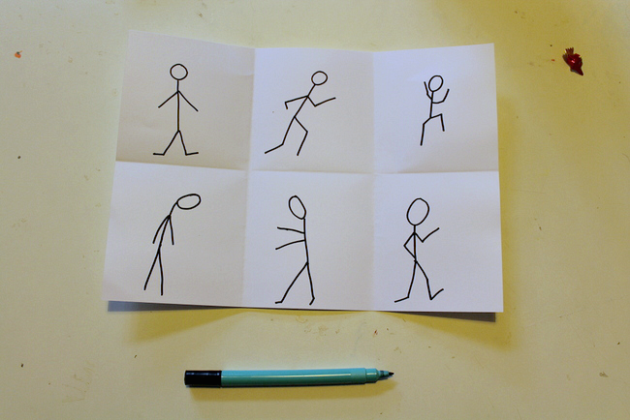
Think about how the simplest of stick-figures can convey strong emotions such as sadness and happiness, and how a few simple lines, drawn in just ten seconds, can show movement and action.
OK, so hopefully now you feel warmed up, your brain has switched off from anything else you were thinking or worrying about, and you are ready for some creativity!
Let’s meet Alberto Giacometti.
Alberto Giacometti was Swiss. He was born in 1901 and died in 1966.
He began painting, drawing, and sculpting from a very early age and explored many art forms throughout his life.

Giacometti’s figure sculptures
He is most famous for his tall, thin figures made of bronze.

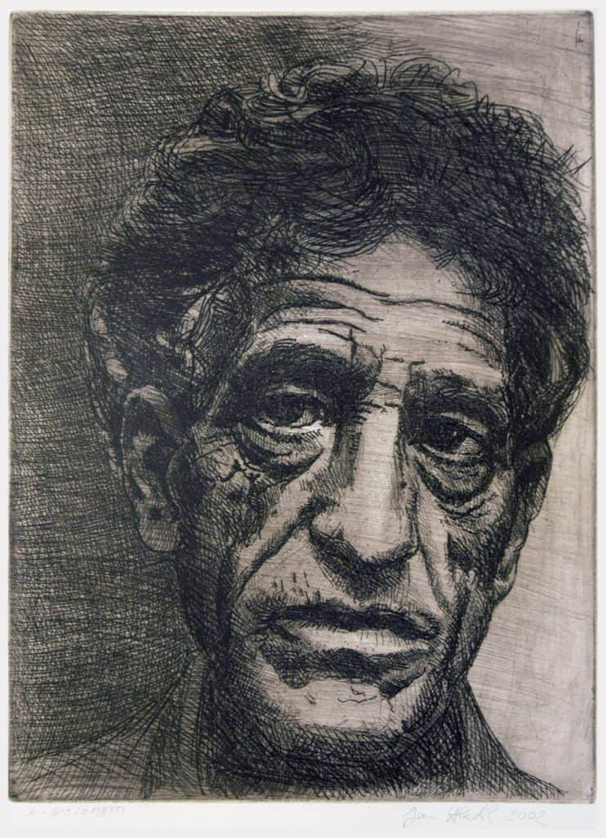

We’re going to turn flat, delicate kitchen foil into sculptures of people, inspired by the textured figures that Giacometti created.

You will need a piece of kitchen foil – a piece a bit bigger than A4

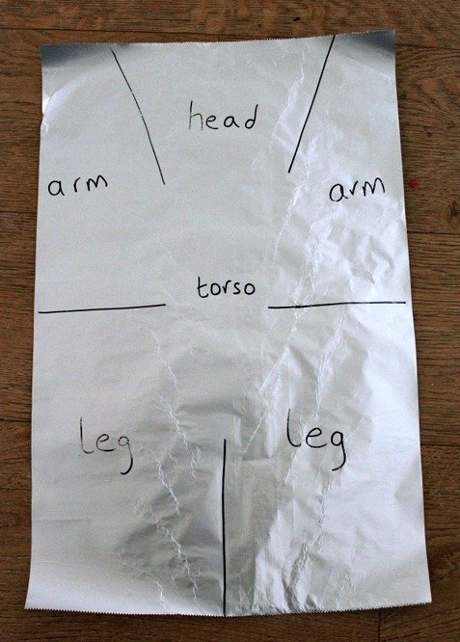

Draw out the guide lines on your own piece of foil, and then cut along them. Next, used your hands to scrunch up the foil sections to make your person.

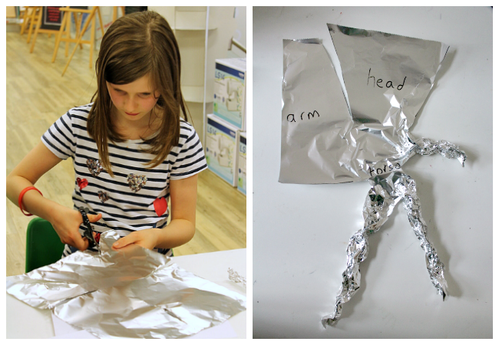

Once you’ve got the idea of how the flat kitchen foil can be sectioned out and scrunched up, you can have fun creating all sorts of different figures.
Move your foil figure to recreate some of the stick figures you have draw. The arms, legs, back, and neck will all bend easily so you can carefully re-position your person.
You can also use additional pieces of foil to make more people.
Try to make your figure stand, run, even do yoga!
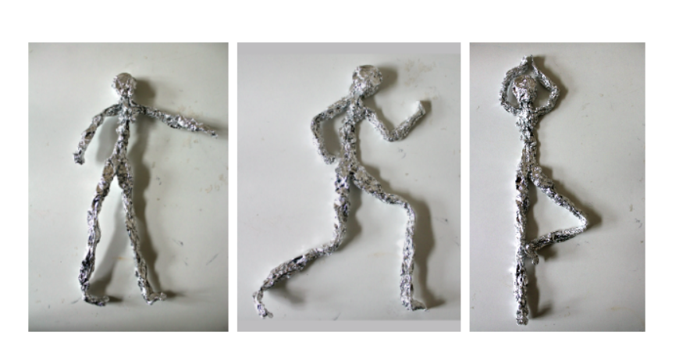
Maybe you can get your sculpture to stand up on its own? This is quite hard, as you need to play around with the balance of your person and their centre of gravity.

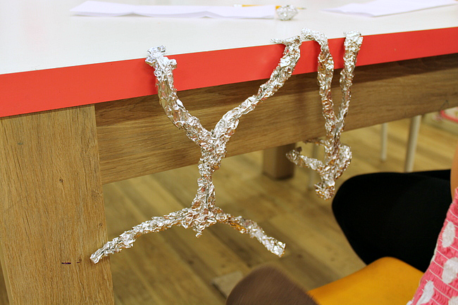

Your figure might like to hang upside down from the table!
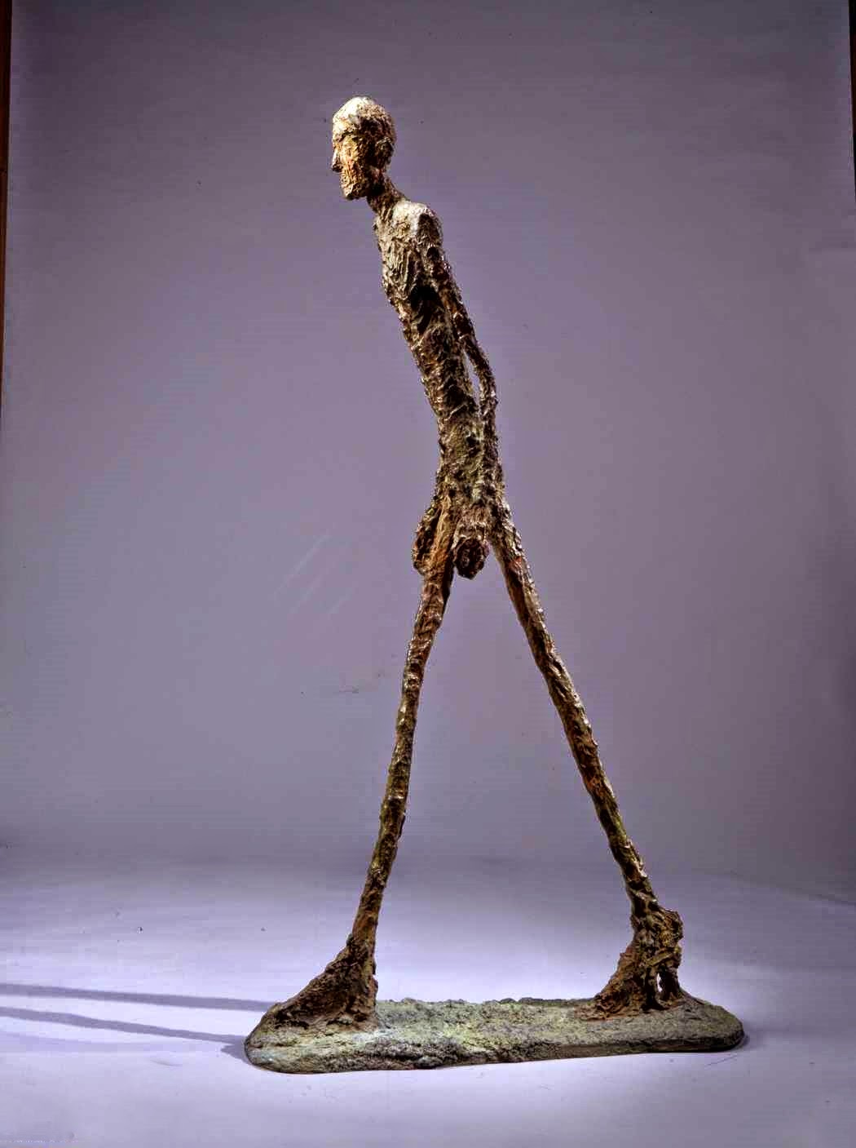
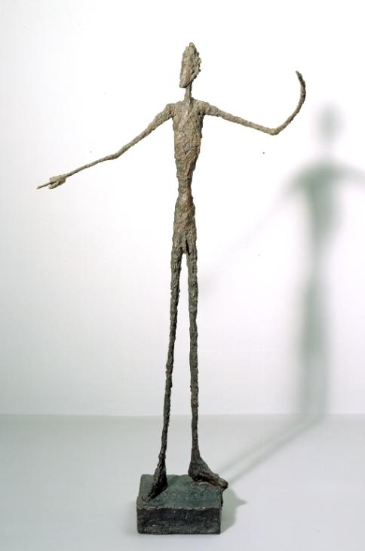
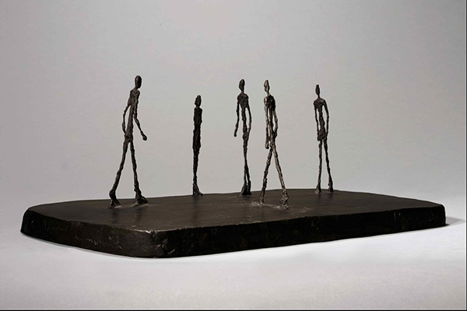
This one is called ‘City square’.
City Square was created by Giacometti in 1948. It shows five thin figures — four men and a woman. These emaciated individuals are in close proximity but appear unable or unwilling to connect with each another.

