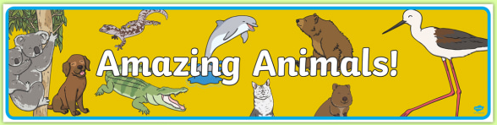

Lesson 1 Learning Objective
- I can spot and name a variety of common animals that are carnivore, herbivore and omnivores.

Warm up your brain!
- Can you remember what carnivore, herbivore and omnivores are? Hopefully you should remember this from Key Stage 1.
- Draw a table with the headings Carnivore, Herbivore and Omnivore. Fill in your table with three animals you know under the headings. Then watch the videos below to see if you were correct!

The facts you need!
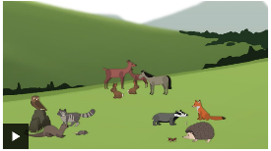
- https://www.bbc.co.uk/bitesize/topics/z6882hv/articles/z96vb9q
(BBC Bitesize - What type of food do animals eat? Part of Science – Animals)


- Ask your adult to help you find this link on YouTube
https://www.youtube.com/watch?v=th2ROcyH8Xw
(How do different animals use their teeth? BBC Teach video on You Tube)
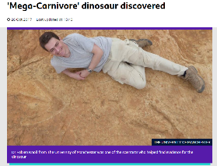
- Read this article about a mega- carnivore that was discovered! https://www.bbc.co.uk/newsround/41764018
(Newsround website - ‘Mega-Carnivore’ dinosaur discovered)

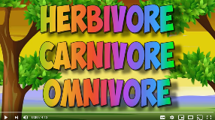
- Ask your adult to help you find this link on YouTube https://www.youtube.com/watch?v=3yrikH2QEFA
(Herbivore, Carnivore, Omnivore Song)

Keep reading…
Your Creative Task…
- Choose any animal you like. Research if your chosen animal is a carnivore, omnivore or herbivore with reasons why.
- Use your imagination and use anything you like to make some sort of model/artwork of your carnivore, omnivore or herbivore – you could use paint, empty packaging, playdough, lego, sewing, knitting, paper plate mask, quilling etc.
- Tweet photographs of your finished model/artwork and a photograph of your written reasons why OR even better still record a video with your model/artwork explaining why it is a carnivore, herbivore or omnivore! If you can’t tweet this then send it by e-mail!
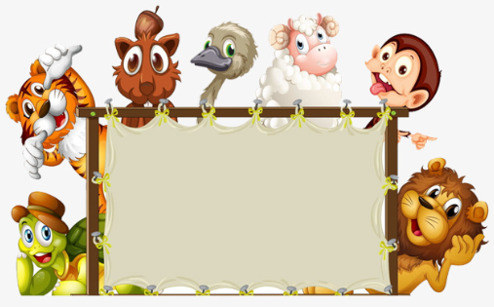

Happy Creating!

