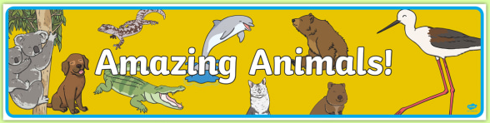

Lesson 3 Learning Objective
- I can describe and compare the structure of a variety of common animals.

Warm up your brain!
What are the six basic types of animals? Don’t peek below! Hopefully you should remember this from Key Stage 1.

The facts you need!
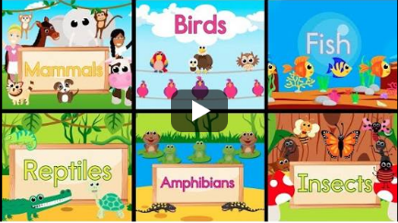
Ask your adult to help you find this on You Tube
https://www.youtube.com/watch?v=PHYi4fqeEdw
(You Tube – Animal Song by Have Fun Teaching)

This video is jam packed with lots of facts about the different animal types. Watch it as many times as you can, sing along, dance along and then finally pause it when you need to so you can write bullet point notes for each animal type.

Your Creative Task…
Create top trump cards for at least two of the animal types or even better create all six!!! Make sure your trump card includes a heading for the animal type, a labelled picture and facts from the video.

Words you could use to label your picture
two eyes legs feathers scaly skin wings claws gills spine
fur fins legs tusks tentacles trunk beak tail

Tweet photographs of your finished top trump cards. If you can’t tweet then send photographs by e-mail!


Our Twitter

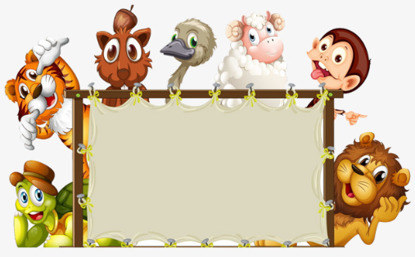

Happy Creating!

