Science – Week 1
Walking Water
Resources needed:
- 3 glasses of equal size
- Paper/kitchen towels
- Water
- Food colouring (only if available)
Instructions.
- Fold 2 pieces of kitchen towel in half and then in half again length ways.
- Next, position 3 glasses between 5 and 8cms apart.
- Half fill the 2 outside glasses. Leave the middle glass empty.
- Take one of the strips of paper towel that you prepared in step 1. Place one end of the paper towel into one glass. Then place the other end into the glass that is empty.
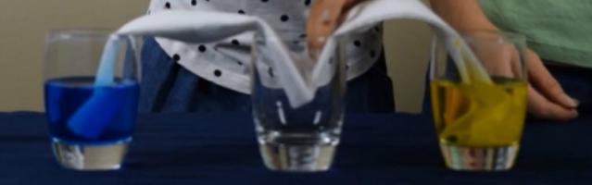
- Take the other strip of paper towel that you prepared in step 1. Place one end of the paper towel into the other glass with the water. Then place the other end into the glass that is empty.
- Observe the experiment right away. Do you notice that the water is “walking” up the paper towel? Now, leave the glasses alone and come back to check on them in an hour or two.
Tip: The longer you wait to check on the glasses, the more water will have moved to the middle glass. The water will stop moving over when all of the cups are filled with the same amount of water.
Why Does the Water Move Between Glasses?
The water appears to defy gravity, but in reality it moves because of a process called capillary action. The adhesive forces between the water and the paper towel are stronger than the cohesive forces inside the water. As a result, the water travels up and across the paper towel out of one glass and into another.

Remember to tweet any pictures and clips to @ChurchHillJS

