Hot: To scan a text to answer questions.

- Write down three things you are told about St. George.
_____________________
_____________________
_____________________

- What impression do you get of the dragon? ________________________________
____________________________________________________________________

- Which picture best represents the cave? Tick one.
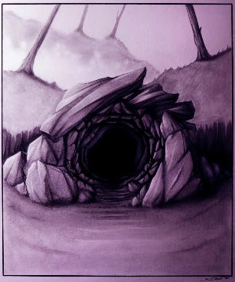

- Using information from the text, tick one box in each row to show whether each statement is true or false.

 | True | False
St. George rode a white horse.
Once a month, the dragon demanded a sacrifice.
The dragon’s cave was in the mountains.
St. George married the princess.

