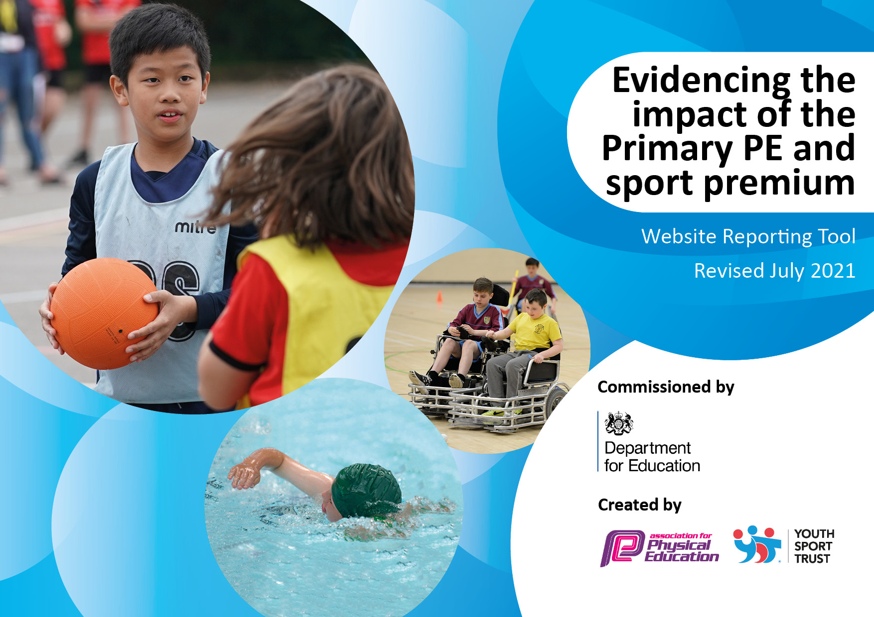
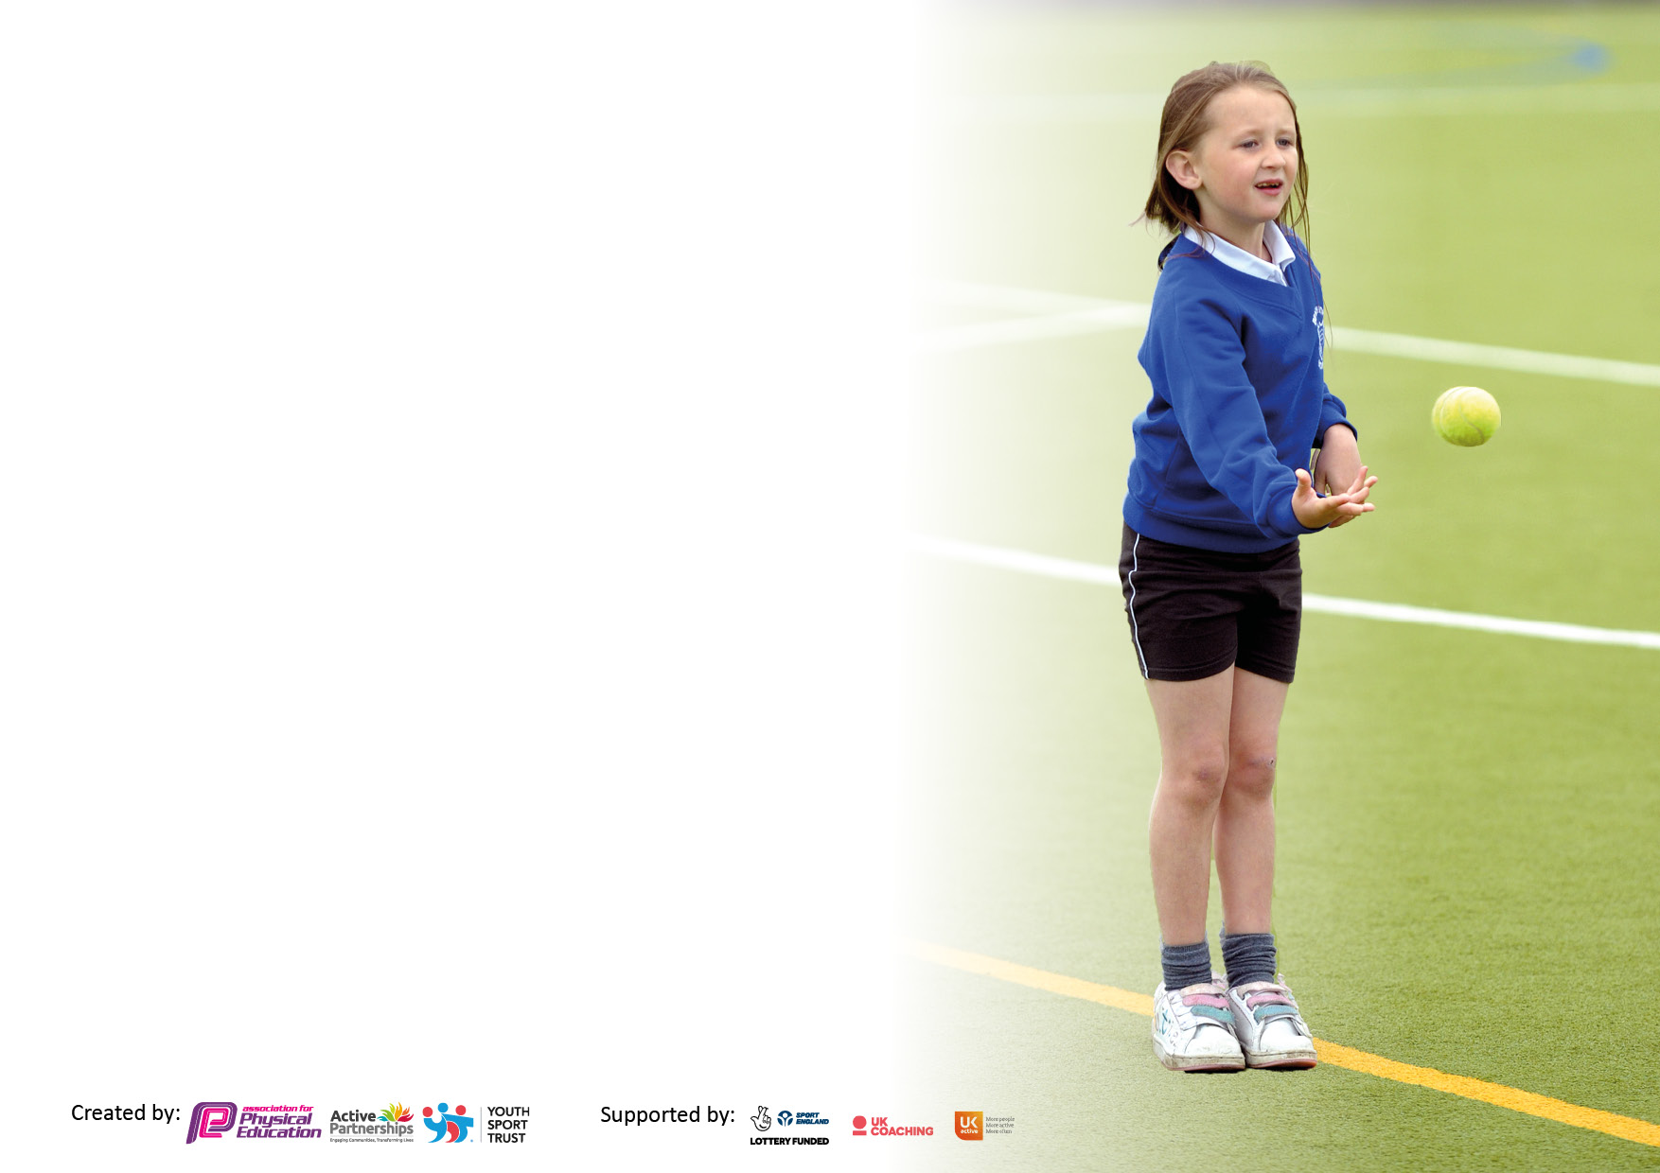

It is important that your grant is used effectively and based on school need. The Education Inspection Framework makes clear there will be a focus on ‘whether leaders and those responsible for governors all understand their respective roles and perform these in a way that enhances the effectiveness of the school’.

Under the Quality of Education Ofsted inspectors consider:
Intent - Curriculum design, coverage and appropriateness
Implementation - Curriculum delivery, Teaching (pedagogy) and Assessment
Impact - Attainment and progress

To assist schools with common transferable language this template has been developed to utilise the same three headings which should make your plans easily transferable between working documents.

Schools must use the funding to make additional and sustainable improvements to the quality of Physical Education, School Sport and Physical Activity (PESSPA) they offer. This means that you should use the Primary PE and sport premium to:

- Develop or add to the PESSPA activities that your school already offer
- Build capacity and capability within the school to ensure that improvements made now will benefit pupils joining the school in future years
- The Primary PE and sport premium should not be used to fund capital spend projects; the school’s budget should fund these.

Pleasevisitgov.ukfortherevisedDfEguidanceincludingthe5keyindicatorsacrosswhichschoolsshoulddemonstrate animprovement.Thisdocumentwillhelpyoutoreviewyourprovisionandtoreportyourspend.DfEencouragesschools to use this template as an effective way of meeting the reporting requirements of the Primary PE and sport premium.

We recommend you start by reflecting on the impact of current provision and reviewing the previous spend.

Schools are required to publish details of how they spend this funding, including any under-spend from 2019/2020, as well as on the impact it has on pupils’ PE and sport participation and attainment. All funding must be spent by 31st July 2022.

We recommend regularly updating the table and publishing it on your website throughout the year. This evidences your ongoing self-evaluation of how you are using the funding to secure maximum, sustainable impact. Final copy must be posted on your website by the end of the academic year and no later than the 31st July 2021. To see an example of how to complete the table please click HERE.

Details with regard to funding
Please complete the table below.

Total amount carried over from 2019/20 | N/a
Total amount allocated for 2020/21 | £ 19,550
How much (if any) do you intend to carry over from this total fund into 2021/22? | £2,800
Total amount allocated for 2021/22 | £19,082
Total amount of funding for 2021/22. To be spent and reported on by 31st July 2022. | £21,882
Swimming Data
Please report on your Swimming Data below.

Meeting national curriculum requirements for swimming and water safety.

N.B. Complete this section to your best ability. For example you might have practised safe self-rescue techniques on dry land which you can then transfer to the pool when school swimming restarts.
Due to exceptional circumstances priority should be given to ensuring that pupils can perform safe self rescue even if they do not fully meet the first two requirements of the NC programme of study
What percentage of your current Year 6 cohort swim competently, confidently and proficiently over a distance of at least 25 metres?  N.B. Even though your pupils may swim in another year please report on their attainment on leaving primary school at the end of the summer term 2020.  Please see note above | 76 %
What percentage of your current Year 6 cohort use a range of strokes effectively [for example, front crawl, backstroke and breaststroke]?  Please see note above | 57%
What percentage of your current Year 6 cohort perform safe self-rescue in different water-based situations? | 53%
Schools can choose to use the Primary PE and sport premium to provide additional provision for swimming but this must be for activity over and above the national curriculum requirements. Have you used it in this way? | Yes/No

Action Plan and Budget Tracking
Capture your intended annual spend against the 5 key indicators. Clarify the success criteria and evidence of impact that you intend to measure to evaluate for pupils today and for the future.

Academic Year: 2021/22 | Total fund allocated: £19,082 | Date Updated: 21/09/2021
Key indicator 1: The engagement of all pupils in regular physical activity – Chief Medical Officers guidelines recommend that primary school pupils undertake at least 30 minutes of physical activity a day in school |  |  |  | Percentage of total allocation:
Intent | Implementation |  | Impact | £8,557=39% of £21,882
Your school focus should be clear what you want the pupils to know and be able to do and about  what they need to learn and to  consolidate through practice: | Make sure your actions to achieve are linked to your intentions: | Funding allocated: | Evidence of impact: what do pupils now know and what can they now do? What has changed?: | Sustainability and suggested next steps:
Using the Real PE Jasmine platform ALL children will develop their physical literacy skills through participation in PE lessons that are inclusive, progressive and in-line with the Real PE multi-ability approach.  Children to work on their Personal, Social, Physical, Cognitive, Health and Fitness, Creative skills  All children’s physical skills will be developed progressively through the delivery and on-going assessment of Real PE (FUNS) activities.  Installation of a daily mile track – Sept payments in this academic year | - Staff to receive twilight training in how to implement Real PE at CHJS  - Staff to receive training in how to use the assessment wheel to assess their class.  - CHJS to purchase annual membership to Jasmine platform to deliver Real PE.  - Sporting equipment replaced and purchased to allow for high quality PE delivery. | £930  £7627 | - All classes in school now using the daily mile track to provide physical activity opportunity (15 minutes daily boost) and provide a brain break. Student voice at the end of the year shows evidence they clearly enjoy this.  - Sports Day 2021 incorporated the new track for the first time to inspire the children to achieve their personal bests.  - Pupil and staff voice overwhelmingly positive about Real PE lessons. | Utilise track to increase PA of children thorough before school, lunch time and after school activities.
Key indicator 2: The profile of PESSPA being raised across the school as a tool for whole school improvement |  |  |  | Percentage of total allocation:
 |  |  |  | £2,900 = 13 % of £21,882
Intent | Implementation |  | Impact
Your school focus should be clear what you want the pupils to know and be able to do and about  what they need to learn and to  consolidate through practice: | Make sure your actions to achieve are linked to your intentions: | Funding allocated: | Evidence of impact: what do pupils now know and what can they now do? What has changed?: | Sustainability and suggested next steps:
Cross Curricular Reading links to other areas of the curriculum through the power of sport and local professional sporting teams | Sept 21 – implement LCFC Reading programme x21 hour sessions for approx. 24 poor readers children from the bottom 20% in each class in yr 4 and Yr 5. | £2,900 | - On going termly monitoring of reading assessments.
Move it Boom NHS & Leicestershire 15 mins Daily Boost initiatives | Children to be given login details for Move it boom to track their activity and earn points. | Free

Key indicator 3: Increased confidence, knowledge and skills of all staff in teaching PE and sport |  |  |  | Percentage of total allocation:
 |  |  |  | £2650 = 12 % of £21,882
Intent | Implementation |  | Impact
Your school focus should be clear | Make sure your actions to | Funding | Evidence of impact: what do | Sustainability and suggested
what you want the pupils to know | achieve are linked to your | allocated: | pupils now know and what | next steps:
and be able to do and about | intentions: |  | can they now do? What has
what they need to learn and to |  |  | changed?
consolidate through practice:
Real PE Inset Training for assessment tool in Jan 2022  To provide staff with CPD to deliver statutory core curriculum swimming opportunities for chd in our school to swim 25m and understand how to carry out a water rescue.  Bespoke Midday supervisor training for the school £150 | Annual membership subscription paid.  Place staff on the Teacher Rescue course courtesy of Future Active – Leicester.  Liaise with AW at South Charnwood School Sport Physical Activity Network (SSPAN) | £500  £2000  £150
Key indicator 4: Broader experience of a range of sports and activities offered to all pupils |  |  |  | Percentage of total allocation:
Intent | Implementation |  | Impact | £6,560 = 29% of £21,882
Your school focus should be clear | Make sure your actions to | Funding | Evidence of impact: what do | Sustainability and suggested
what you want the pupils to know | achieve are linked to your | allocated: | pupils now know and what | next steps:
and be able to do and about | intentions: |  | can they now do? What has
what they need to learn and to |  |  | changed?:
consolidate through practice:
Implement an inclusive extra curricular sports programme by hiring the services of a sports coach from Metcalf Sports and Little Springers Gymnastic. | £1,520 for x2 Pre-school activities throughout the year  £4560 for x3 After school activities throughout the year  £480 for 12 weeks Gymnastics specialist coaching | £6,560 |  | Staff to be invited to observe Mr Headley our after school sports coach deliver a variety of sport sessions throughout the year.

Key indicator 5: Increased participation in competitive sport |  |  |  | Percentage of total allocation:
 |  |  |  | £1500 = 7% of £21,882
Intent | Implementation |  | Impact
Your school focus should be clear | Make sure your actions to | Funding | Evidence of impact: what do | Sustainability and suggested
what you want the pupils to know | achieve are linked to your | allocated: | pupils now know and what | next steps:
and be able to do and about | intentions: |  | can they now do? What has
what they need to learn and to |  |  | changed?
consolidate through practice:
- Retain Full membership to the South Charnwood School Sport Physical Activity Network (SSPAN) to provide pathways for local, county and national school games sports competitions.  - Affiliation fees to Leicestershire Cross Country, Wreake Valley Football league | Correspond with AW at the SSPAN in Sept 2021  Create a staff rota to attend local events.  Organise after school club programme to coincide with the school games calendar. | £1300  £100

Signed off by
Head Teacher: | D Brown
Date: | 15/07/21
Subject Leader: | Mr S Partner
Date: | 15/07/21
Governor:
Date:

