St George and the Dragon

Long, long ago, there was a small village with stone houses at the foot of a snow-capped mountain. One day, a brave knight called St George was passing by the village. St. George was a valiant and handsome knight with glimmering armour and a deadly blade. He carried a mighty shield and rode on the back of a noble, white stallion. When he arrived at the village, he found the villagers in distress because of a villainous dragon who terrorised the area.
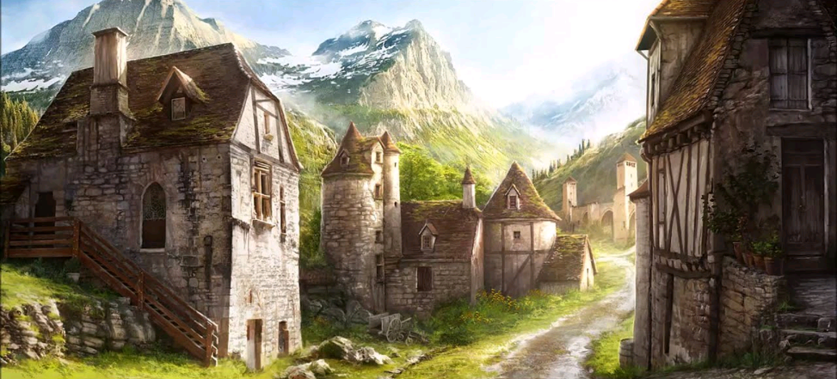

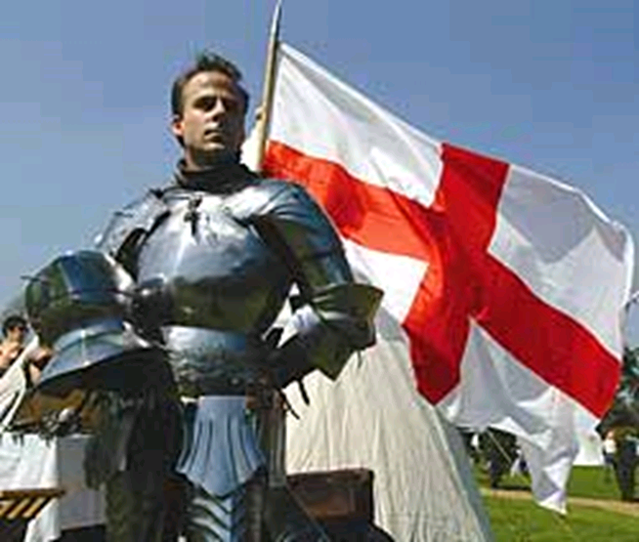
“Help us!” the villagers cried. “The dragon demands the sacrifice of a beautiful maiden every day and now he is going to eat our princess!”
“Lead me to this beast!” cried St. George. “I will slay the dragon and save the princess.”

Then, St George rode along the cart track high into the mountains until he found the dragon’s lair. It was a vast cavern with large boulders and sharp stalactites. The princess was tied to a tree in front of the cave.
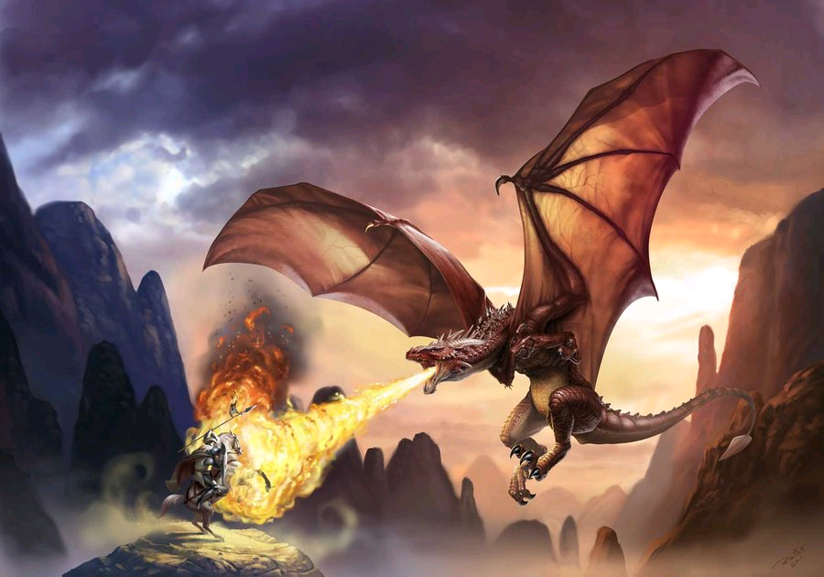
Suddenly, a terrifying ROAR rang out, echoing across the mountains. There was a colossal dragon with razor sharp teeth and malicious eyes. His wing-span was huge and his jaws were immense. With another roar the dragon blasted an enormous fireball from its mouth. St. George raised his shield and the flames hissed around the edges.
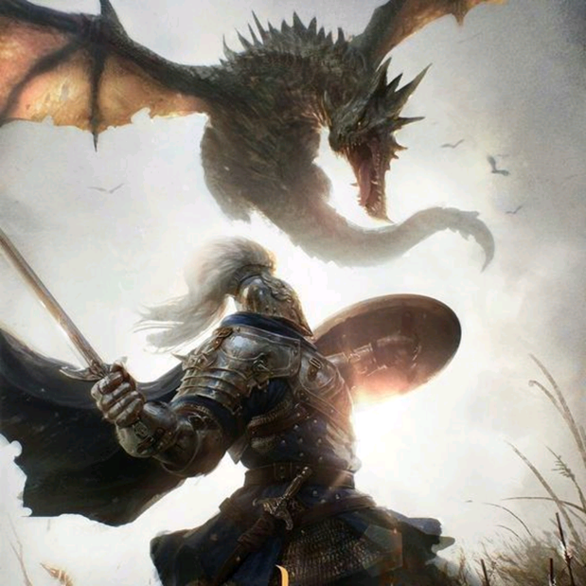
St. George charged at the dragon and smote him a strong blow but his scales were as hard as emeralds. More fire leapt from the dragon’s jaws and he unfurled his wings.

At that moment, St. George spotted a bare patch on the dragon’s hind leg. He plunged in his sword and blood erupted from the wound. The wicked beast gave a final shriek and came down with a mighty THUD! St. George had slain the dragon.
Next, he gently untied the princess and led her back to the village. There was wild cheering from the crowds. Finally, a magnificent feast was held in honour of St. George and his glorious victory. The villagers could now live in peace and St. George’s battle with the dragon would be remembered for all time.

